IT 360 Cloud Integration | Week 1 | Lab 1
AWS to GCP: Image Creation and Migration
Click-by-click console steps with screenshots, and the matching Cloud Shell commands, for moving the apacheserver1 web server from Amazon EC2 to Google Compute Engine
Course: IT 360-01 Cloud Integration, Ensign College
Instructor: Jackson Isiko, Ph.D.
Routes covered: the disk-copy route everyone can do (Parts A to E), plus the AWS AMI export with Google Image Import and the Google Migrate to Virtual Machines AWS connector (Part C-alt).
Companion documents: Lab 1 Student Guide - AWS to GCP Apache Migration (full guide with expected results and troubleshooting) and Lab 1 Migration Workflow (the phase overview).
Version: 2026-10-29; commands re-validated on 2026-10-31. Screenshots were taken from the live consoles on 2026-10-28 and 2026-10-29; AWS and Google change their consoles often, so a button may have moved a little by the time you read this. The names of the buttons stay the same.

How to use this document
Each step has two parts. The Console box tells you where to click, and the screenshot below it shows the same clicks as red numbered boxes. Under every screenshot a What you see paragraph explains the page, each numbered mark, and anything in the picture that will look different on your account. The Cloud Shell block gives the commands that do exactly the same thing from a terminal. Do the step one way or the other, not both. The console path is easier the first time; the commands are faster the second time and are what the lab scripts use.
Mac users: before pasting commands into Terminal. The Mac Terminal runs zsh, which does not treat # as a comment when you paste a line, so a line such as ... | grep NODE # note fails with grep: #: No such file or directory. Run setopt interactivecomments once in each new Terminal window and the comments are ignored. Replace every <...> placeholder, angle brackets included, before running a line: zsh and bash both read <word> as "take input from the file word" and fail with no such file or directory. Cloud Shell runs bash and needs only the second rule.
Two different shells appear in this guide. AWS CloudShell is the >_ icon at the top of the AWS console, and it has the aws command. Google Cloud Shell is the >_ icon at the top of the Google Cloud console, and it has gcloud, curl and tar; Step 12 installs qemu-img with apt-get. Steps 6 to 8 and 11 are typed on the Ubuntu server itself, over SSH.
Use these names throughout. If you are on the Vocareum AWS sandbox, the region is us-east-1 (N. Virginia), the key pair is vockey (file labsuser.pem) and the instance type is t2.micro; the clicks are otherwise the same.
Item | Value used in this guide | Yours
AWS region | US East (Ohio), us-east-2
EC2 instance | apacheserver1, Ubuntu Server 22.04 LTS, t3.micro
Key pair | apacheserver1-key (file apacheserver1-key.pem)
Security group | apacheserver1-sg: SSH from My IP, HTTP from anywhere
Scratch volume | apacheserver1-scratch, 10 GiB gp3, same AZ as the instance, device /dev/sdf
GCP project | <PROJECT_ID> (your own project; the Vocareum GCP lab cannot create firewall rules)
Cloud Storage bucket | <PROJECT_ID>-apache-migration-aws, us-central1
Compute Engine image | apacheserver-image-aws
GCP VM | apacheserver-gcp-aws, us-central1-a, e2-micro, network tag http-server
Firewall rule | allow-http: TCP 80 from 0.0.0.0/0 to tag http-server

Watch out
Three rules that keep this lab safe: open SSH to My IP only, never to 0.0.0.0/0. Remove the public disk.qcow2 link as soon as the download is done (Step 11). Delete everything in Part E when you have your screenshots; both clouds bill until you do.

Part A. Build the Apache server in AWS (Phase 1)

Step 1. Launch the Ubuntu instance
Console: where to click
Set the region selector (top right) to US East (Ohio) us-east-2, open EC2 → Instances, and click Launch instances (1).
Name (2): apacheserver1. Under Application and OS Images click the Ubuntu tile (3). The Quick Start list no longer offers plain 22.04, so click Browse more AMIs (4), open the Community AMIs tab (5), paste ubuntu/images/hvm-ssd/ubuntu-jammy-22.04-amd64-server into the search box (6) and press Enter, then click Select (7) on the newest one whose Owner is 099720109477 (Canonical).
Instance type (8): t3.micro (t2.micro on Vocareum). Key pair: click Create new key pair (9), name it apacheserver1-key (10), keep RSA and .pem (11), click Create key pair (12). The browser downloads apacheserver1-key.pem; move it to ~/.ssh/ and run chmod 400 ~/.ssh/apacheserver1-key.pem.
Network settings: leave Create security group selected. Tick Allow SSH traffic from (13) and change the source to My IP (14). Tick Allow HTTP traffic from the internet (15). Leave HTTPS unticked.
Configure storage: 8 GiB gp3 (16) is enough. In the Summary panel click Launch instance (17). On the success page click the instance ID, then note its Public IPv4 address and Instance ID.

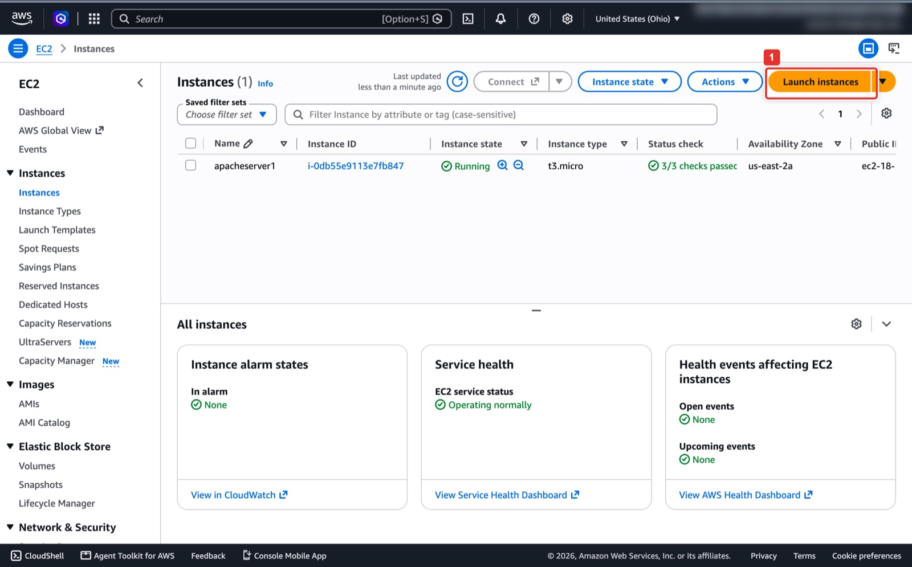
Figure 1. EC2 → Instances → Launch instances.
What you see: The EC2 → Instances page in the Ohio region. The left menu lists Instances, Images (AMIs), Elastic Block Store (Volumes) and Network & Security; every AWS step in this guide starts from here. The orange Launch instances button (1) opens the wizard. The instructor's account already shows a running apacheserver1; your list will be empty.
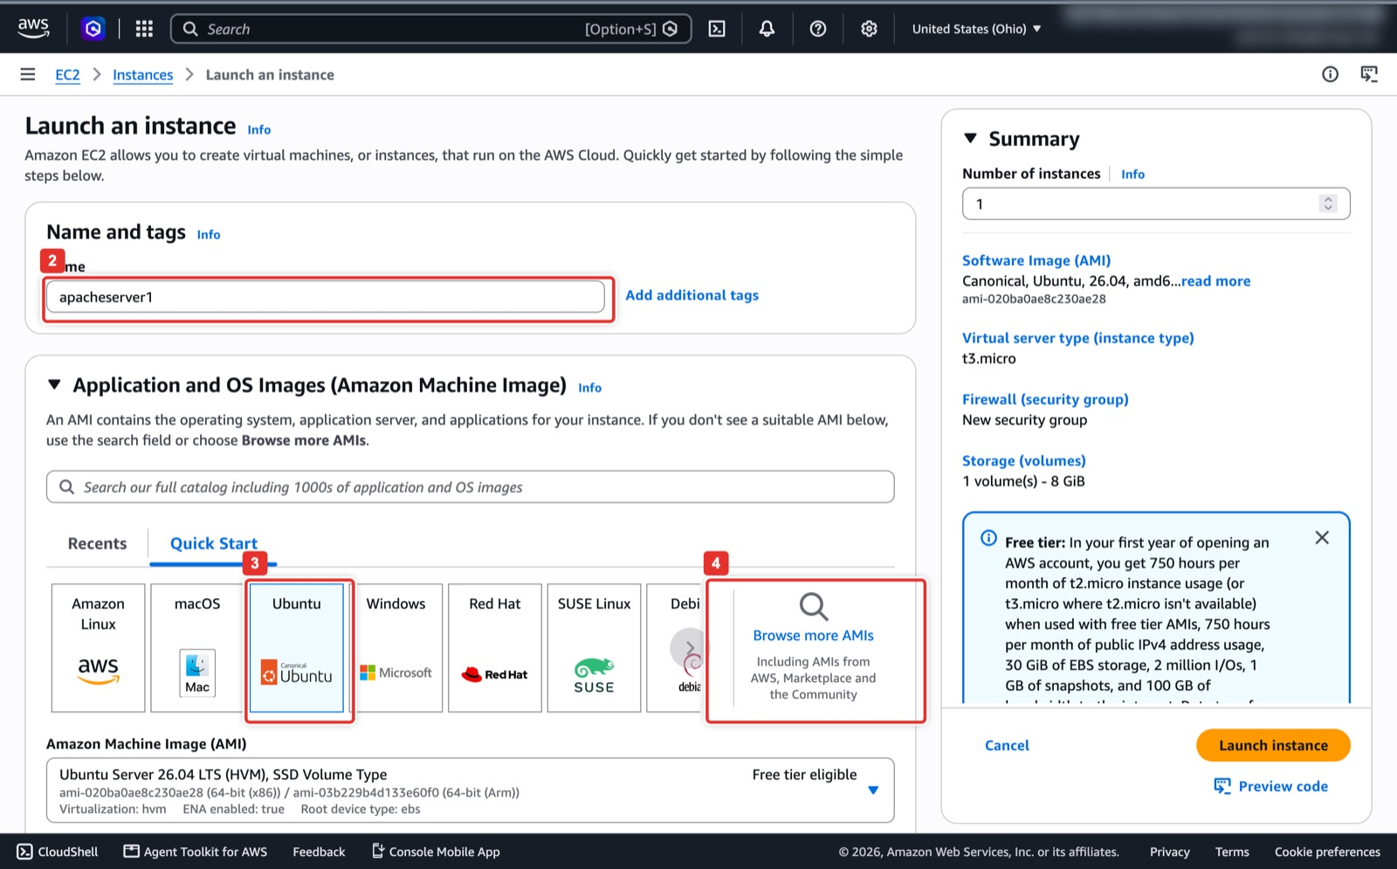
Figure 2. Name the instance, pick the Ubuntu tile, then Browse more AMIs for 22.04.
What you see: The top of the Launch an instance wizard. Name and tags (2) is where you type apacheserver1. In Application and OS Images the Ubuntu tile (3) is selected, but its dropdown only offers Ubuntu Server 26.04 and 24.04, so you must click Browse more AMIs (4) to reach 22.04. The Summary panel on the right updates as you make choices.
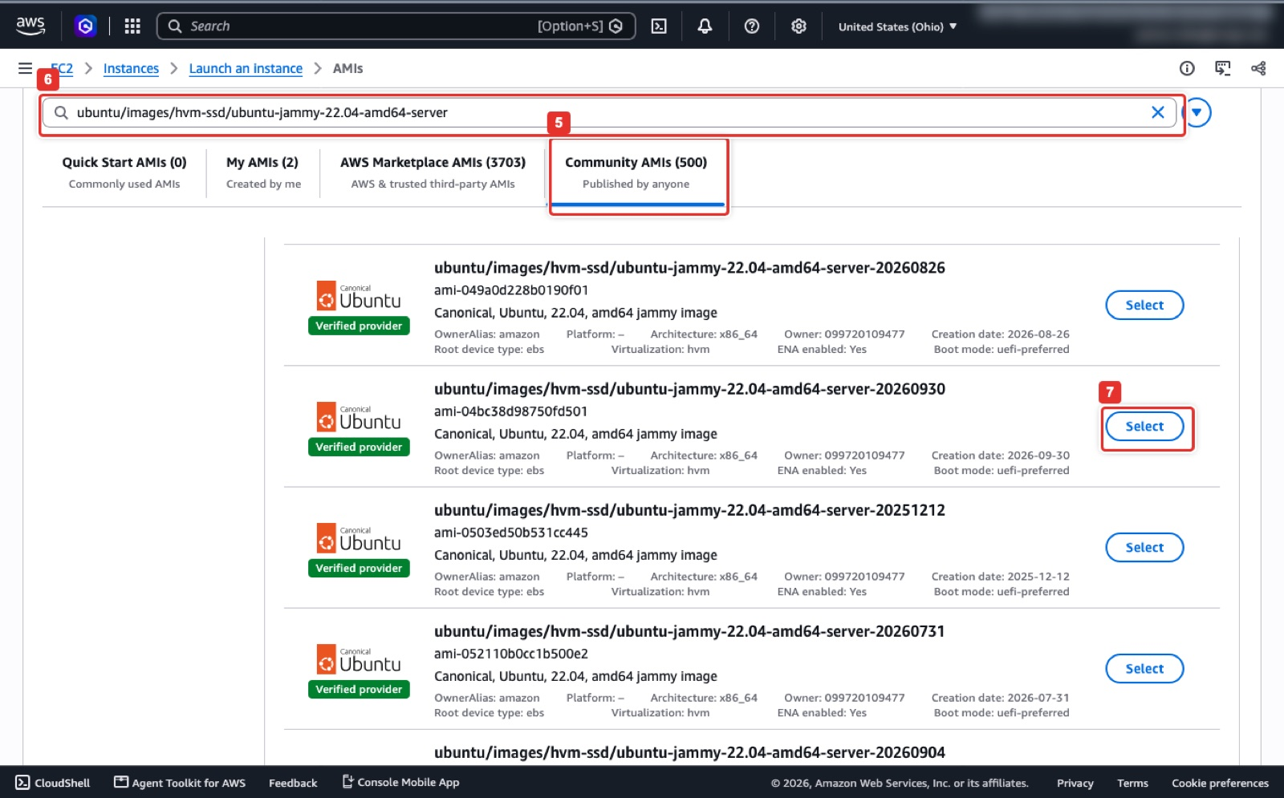
Figure 3. Community AMIs tab, search for the Canonical jammy 22.04 server image, Select the newest one.
What you see: The AMI catalog. The search box (6) holds the Canonical image name and the Community AMIs tab (5) shows the matches. Each card lists the AMI ID, Owner 099720109477 and a Creation date. The list is not sorted by date, so compare the dates and click Select (7) on the newest one (20260930 here). Ignore AWS Marketplace results, which can carry extra charges.
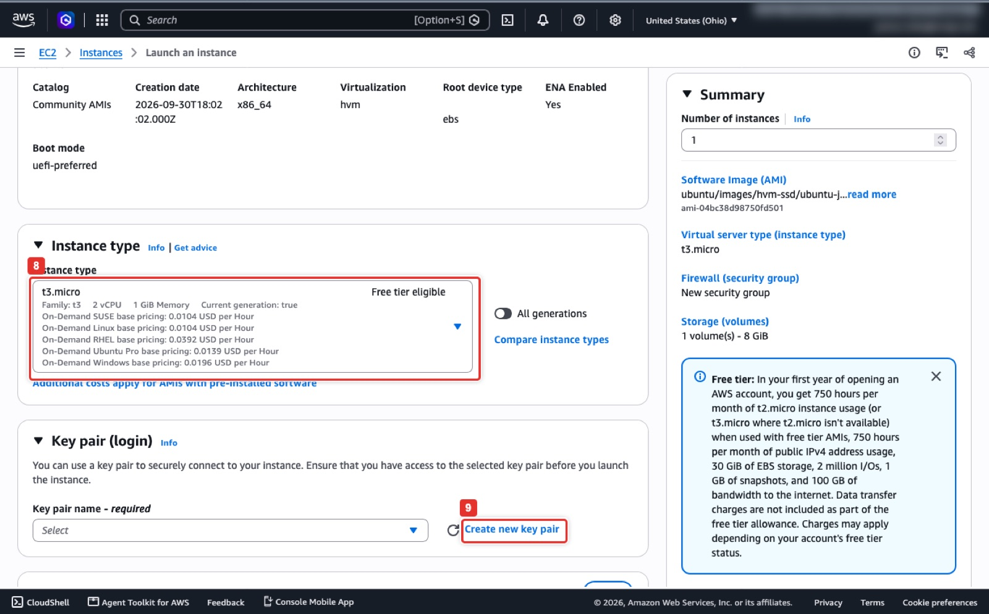
Figure 4. Instance type t3.micro and Create new key pair.
What you see: Further down the wizard. The Instance type box (8) shows t3.micro, free tier eligible, 2 vCPU and 1 GiB; if it shows something else, open the dropdown and search for t3.micro. In Key pair (login) the Key pair name dropdown is still empty; click Create new key pair (9) to open the dialog in the next figure.
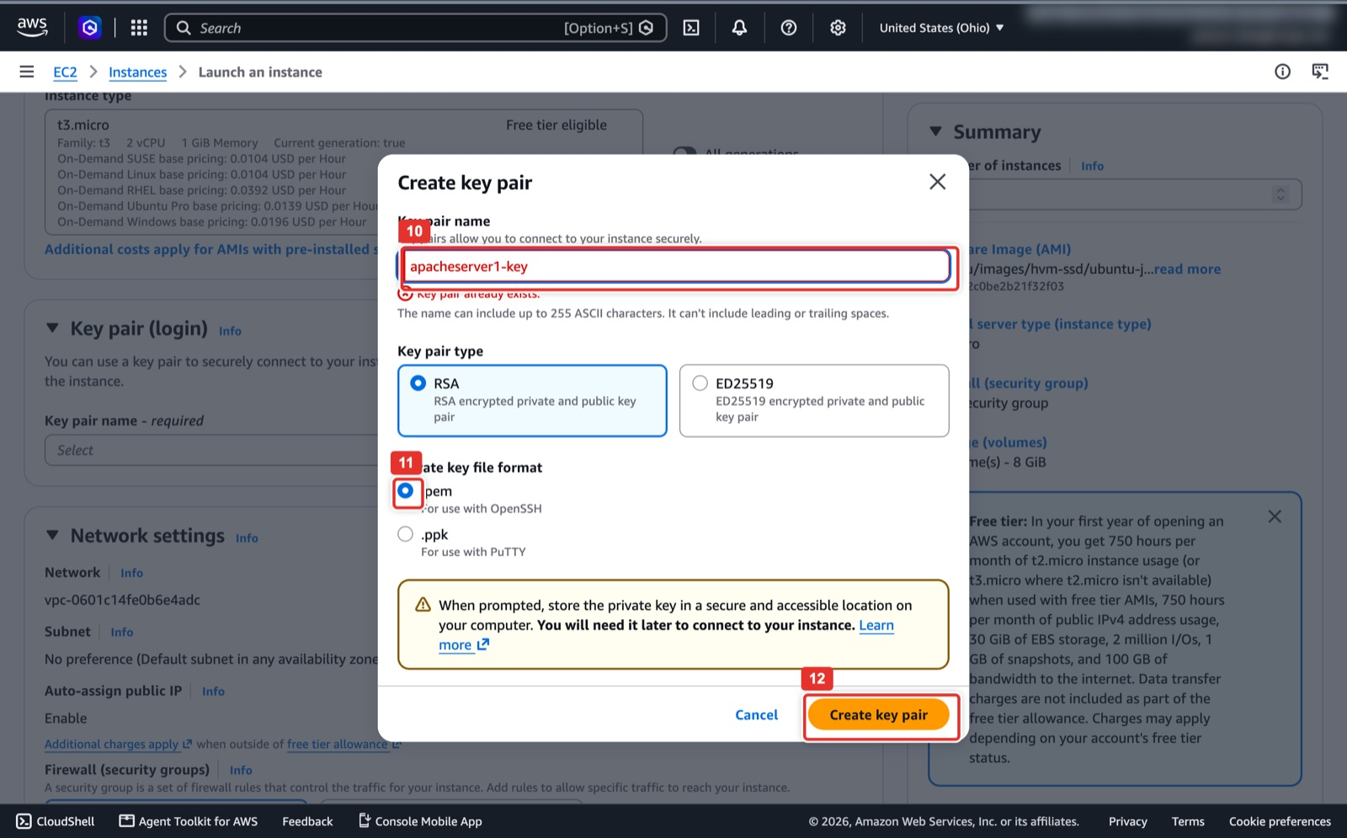
Figure 5. Key pair dialog: name, .pem format, Create key pair.
What you see: The Create key pair dialog. Type apacheserver1-key in Key pair name (10). Keep Key pair type RSA and Private key file format .pem (11), then click Create key pair (12). The red "Key pair already exists" message appears only because the instructor's account already had one; you will not see it. The browser downloads the .pem file immediately and AWS never shows it again.
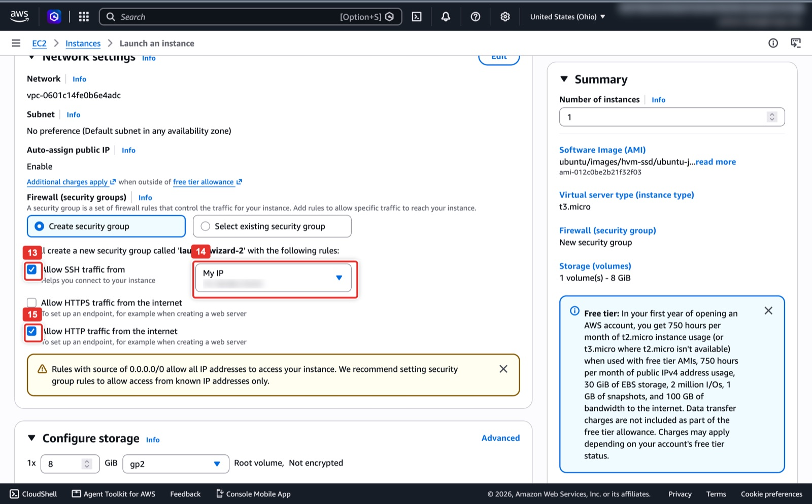
Figure 6. Security group rules: SSH from My IP only, HTTP from the internet.
What you see: Network settings with Create security group selected. Tick Allow SSH traffic from (13) and change its source dropdown to My IP (14); the box fills with your public address (blurred here). Tick Allow HTTP traffic from the internet (15) and leave HTTPS unticked. The yellow warning about 0.0.0.0/0 refers to the HTTP rule and is expected for a web server.
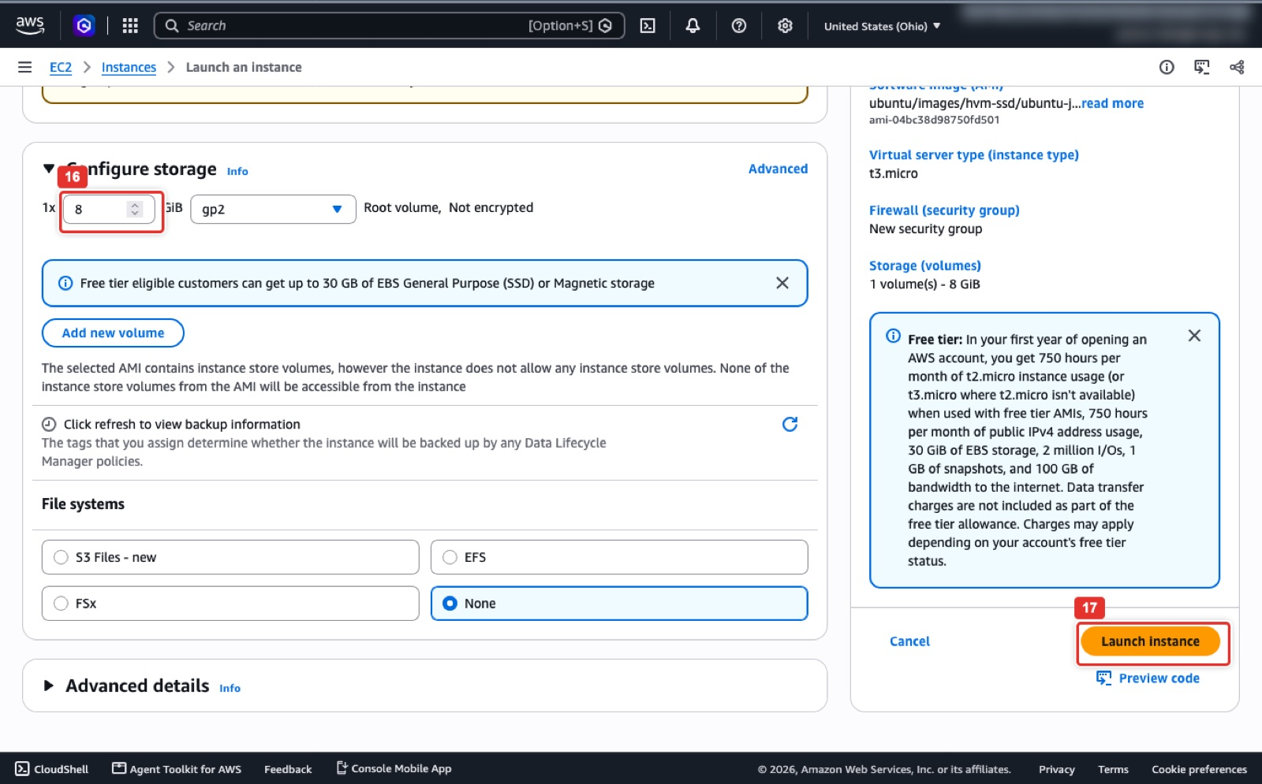
Figure 7. 8 GiB root volume, then Launch instance in the Summary panel.
What you see: Configure storage and the Summary panel. The root volume size field (16) reads 8 GiB (gp2 or gp3 are both fine). Do not add a second volume here; the scratch disk is added in Step 5. When the Summary shows 1 instance, your Ubuntu AMI, t3.micro and a new security group, click Launch instance (17).
AWS CloudShell (same result; set the region first)
export AWS_DEFAULT_REGION=us-east-2
mkdir -p ~/.ssh && chmod 700 ~/.ssh
aws ec2 create-key-pair --key-name apacheserver1-key --query KeyMaterial --output text > ~/.ssh/apacheserver1-key.pem
chmod 400 ~/.ssh/apacheserver1-key.pem
VPC=$(aws ec2 describe-vpcs --filters Name=isDefault,Values=true --query 'Vpcs[0].VpcId' --output text)
SG=$(aws ec2 create-security-group --group-name apacheserver1-sg --description "SSH and HTTP for apacheserver1" --vpc-id $VPC --query GroupId --output text)
MYIP=$(curl -s https://checkip.amazonaws.com)
aws ec2 authorize-security-group-ingress --group-id $SG --ip-permissions \
IpProtocol=tcp,FromPort=22,ToPort=22,IpRanges="[{CidrIp=$MYIP/32}]" \
IpProtocol=tcp,FromPort=80,ToPort=80,IpRanges="[{CidrIp=0.0.0.0/0}]"
AMI=$(aws ec2 describe-images --owners 099720109477 \
--filters 'Name=name,Values=ubuntu/images/hvm-ssd/ubuntu-jammy-22.04-amd64-server-*' 'Name=state,Values=available' \
--query 'sort_by(Images,&CreationDate)[-1].ImageId' --output text)
ID=$(aws ec2 run-instances --image-id $AMI --instance-type t3.micro --key-name apacheserver1-key \
--security-group-ids $SG --associate-public-ip-address \
--tag-specifications 'ResourceType=instance,Tags=[{Key=Name,Value=apacheserver1}]' \
--query 'Instances[0].InstanceId' --output text)
aws ec2 wait instance-running --instance-ids $ID
IP=$(aws ec2 describe-instances --instance-ids $ID --query 'Reservations[0].Instances[0].PublicIpAddress' --output text)
echo "Instance $ID Security group $SG Public IP $IP"

Note
CloudShell keeps a separate home directory per region, and its outgoing IP is not your laptop's IP. If you create the key pair in CloudShell, the .pem lives there; if you later SSH from CloudShell, add its IP (curl -s https://checkip.amazonaws.com inside CloudShell) to the SSH rule, and remove it afterwards.

Step 2. Connect over SSH
Console: where to click
EC2 → Instances, tick apacheserver1 (1), click Connect (2).
Open the In SSH client tab (3). It prints the exact chmod and ssh -i commands for your key and public DNS (4). Copy the ssh line into a terminal on your laptop.

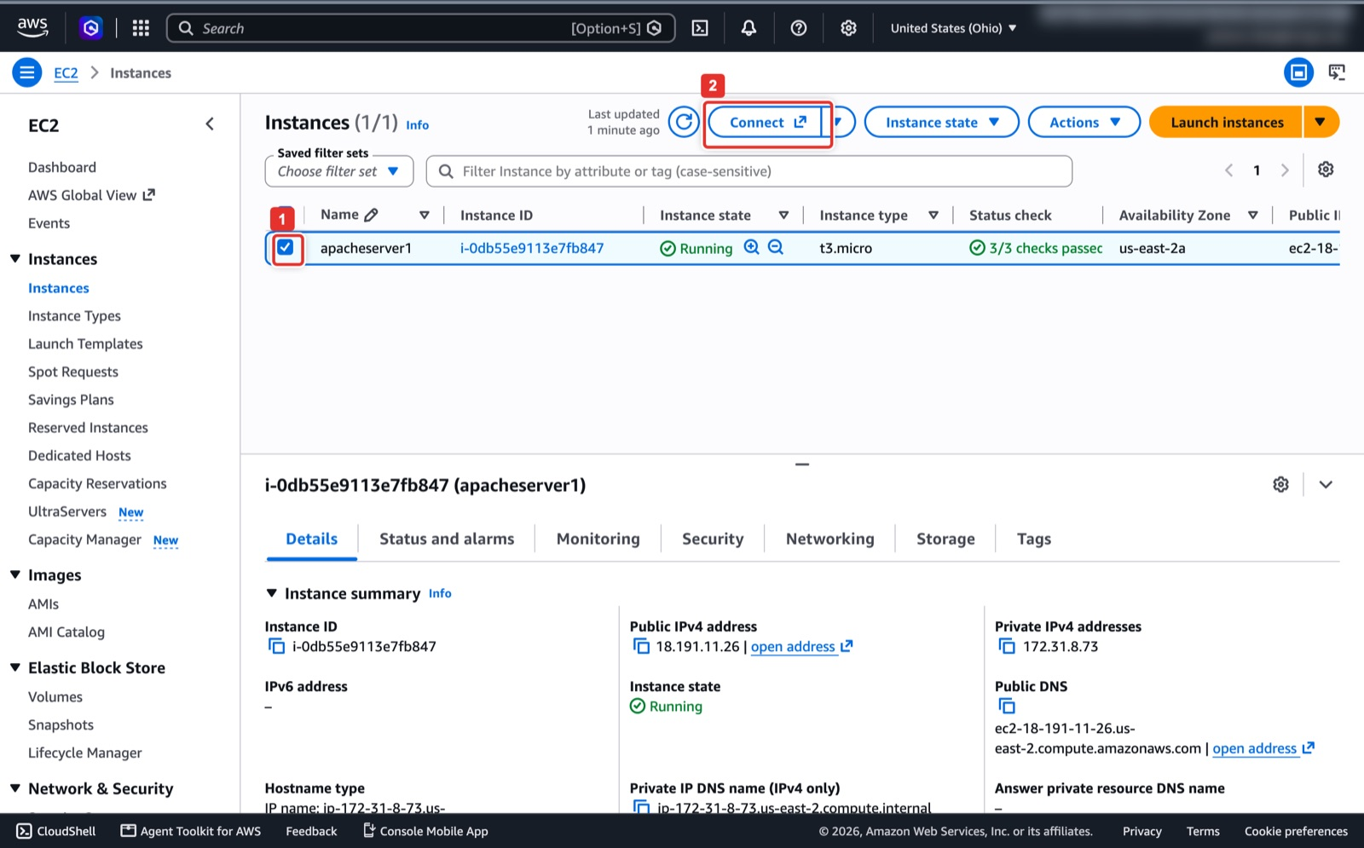
Figure 8. Select the instance and click Connect.
What you see: Back on the Instances page the new instance is Running with 3/3 checks passed. Tick its checkbox (1) and the details pane opens underneath with the Instance ID, Public IPv4 address and Public DNS you will need. Connect (2) at the top opens the connection page.
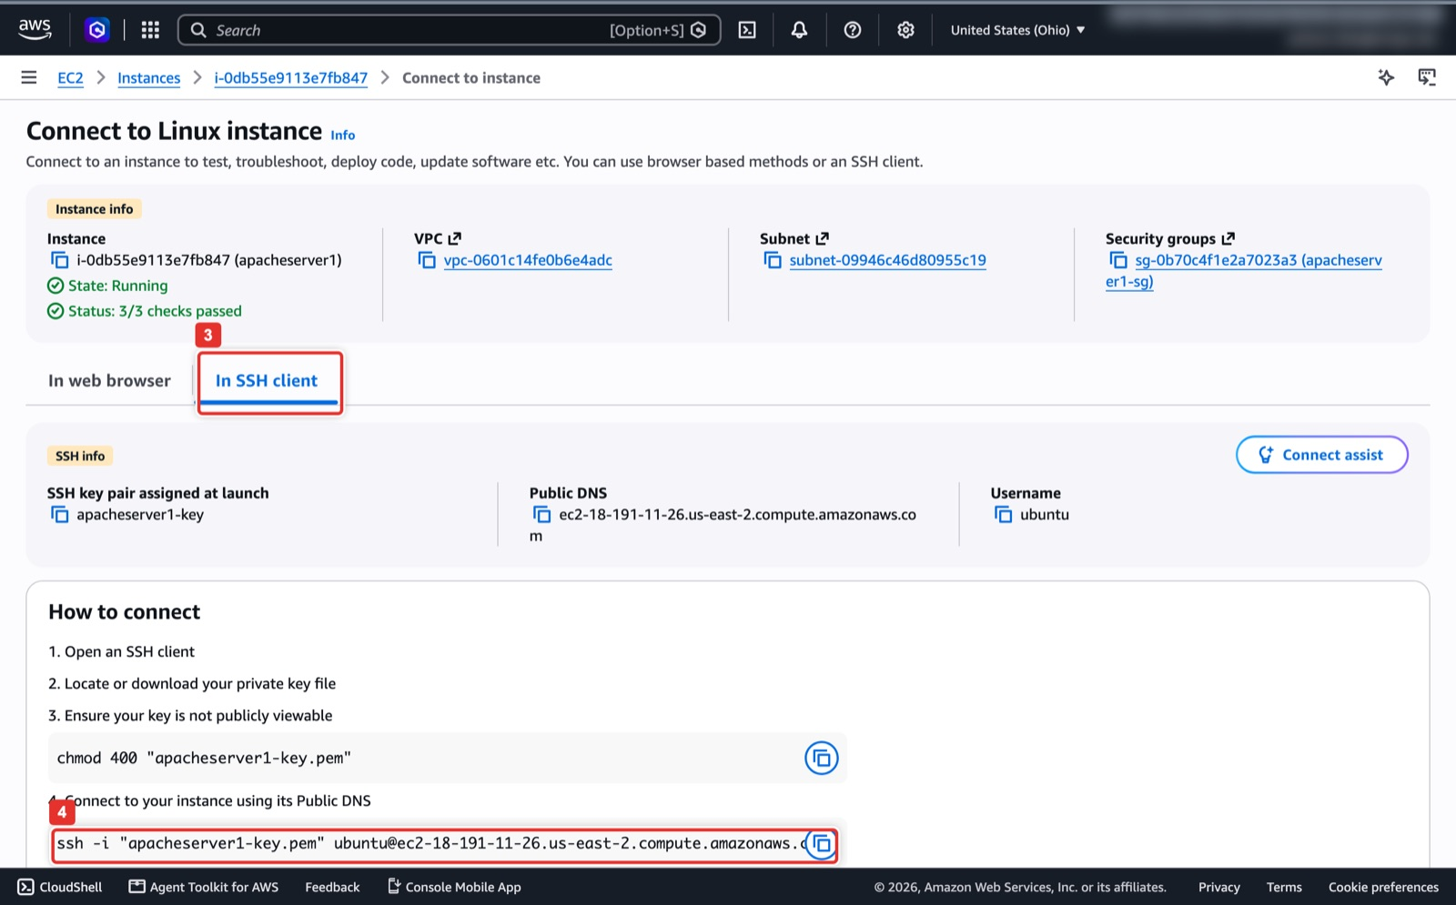
Figure 9. The SSH client tab gives you the ready-made ssh command.
What you see: The Connect to instance page. Its In SSH client tab (3) lists the key pair assigned at launch, the public DNS name and the username ubuntu. The last line (4) is the complete ssh -i command; use the copy icon next to it and paste it into a terminal opened in the folder that holds your .pem file.
Terminal on your laptop
chmod 400 ~/.ssh/apacheserver1-key.pem
ssh -i ~/.ssh/apacheserver1-key.pem ubuntu@<EC2_PUBLIC_IP>

Expected result
A prompt that reads ubuntu@ip-172-31-x-x:~$. If it hangs, your public IP changed: edit the security group SSH rule (Step 11 shows where) to your current IP.

Steps 3 and 4. Install Apache and verify it
On the EC2 instance (SSH session)
sudo apt update && sudo apt install -y apache2
sudo systemctl enable --now apache2
systemctl is-active apache2 # active
curl -sI http://localhost/ | head -1 # HTTP/1.1 200 OK

Open http://<EC2_PUBLIC_IP>/ in your browser. The page titled Apache2 Ubuntu Default Page: It works is Checkpoint 1; take the screenshot now.

Part B. Prepare the OS and capture the disk (Phases 2 and 3)

Step 5. Add a 10 GiB scratch volume
The image of the root disk cannot be written onto the root disk itself, so attach a second small disk to hold it.
Console: where to click
EC2 → Elastic Block Store → Volumes → Create volume (1).
Size 10 GiB (2), type gp3. Availability Zone (3) must be the same AZ as the instance, shown in the instance list (us-east-2a in the screenshots). Add a tag with Key Name (4) and Value apacheserver1-scratch (5), then Create volume (6).
Back in the Volumes list tick the new volume (7), open Actions (8) → Attach volume (9). Choose instance apacheserver1, device name /dev/sdf, click Attach volume. The state changes from Available to In-use.

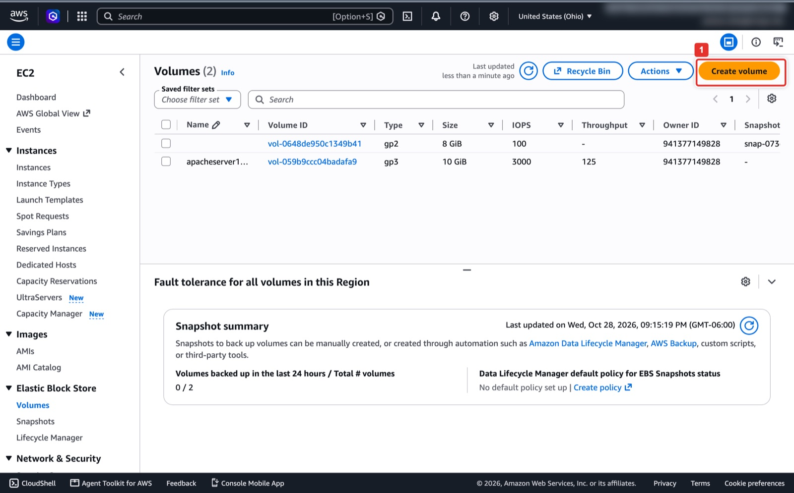
Figure 10. Volumes → Create volume.
What you see: EC2 → Elastic Block Store → Volumes. The list shows the 8 GiB root volume of the instance (no name) and, in the instructor's account, a scratch volume from an earlier run. Create volume (1) opens the form.
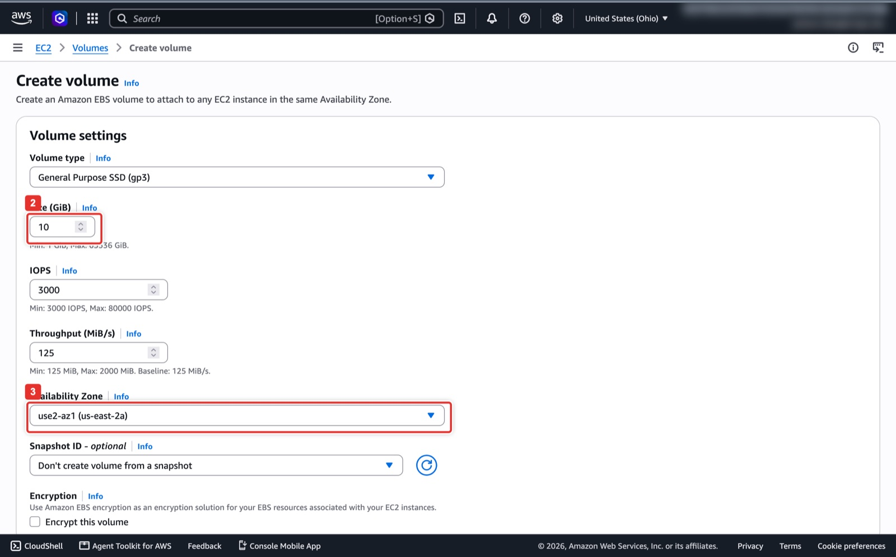
Figure 11. Size 10 GiB and the same Availability Zone as the instance.
What you see: The Create volume form. Volume type stays General Purpose SSD (gp3). Set Size (2) to 10 GiB and leave IOPS and throughput at their defaults. Availability Zone (3) must match the instance's zone from the Instances list (us-east-2a here); a volume in another zone cannot be attached.
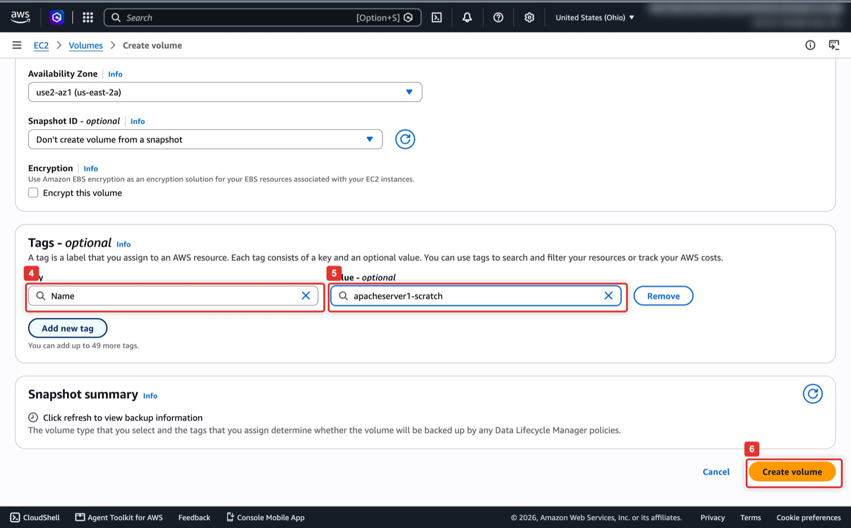
Figure 12. Name tag, then Create volume.
What you see: The bottom of the same form. Under Tags enter Key Name (4) and Value apacheserver1-scratch (5) so the volume shows a name in the list, then click Create volume (6). Encryption and snapshot stay off.
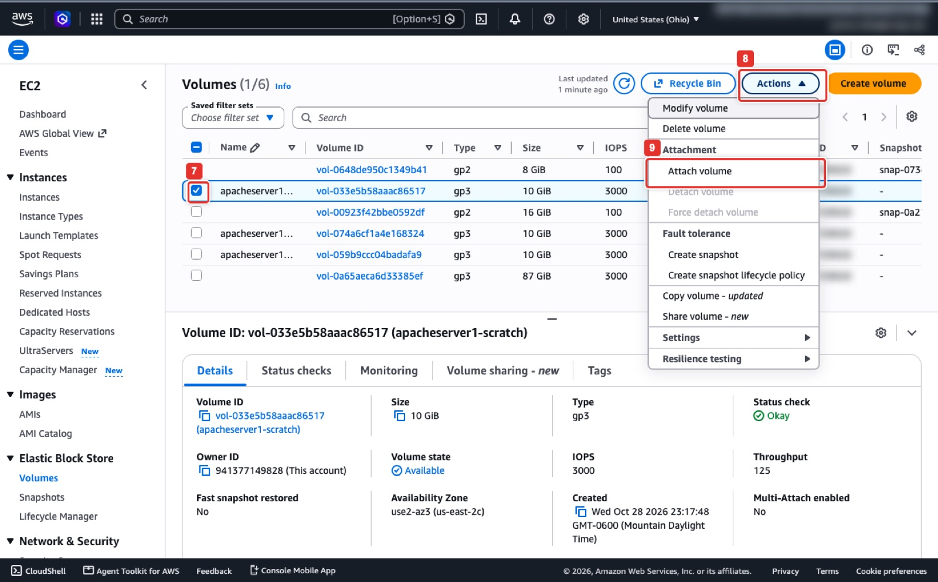
Figure 13. Select the volume, then Actions → Attachment → Attach volume.
What you see: The Volumes list after creation. Tick the new volume (7); its state must read Available. Open Actions (8) and click Attach volume (9) under Attachment. If Attach volume is greyed out, the ticked volume is already attached or sits in a different zone. The next page asks for the instance (apacheserver1) and the device name /dev/sdf.
AWS CloudShell
I=<INSTANCE_ID>
AZ=$(aws ec2 describe-instances --instance-ids $I --query 'Reservations[0].Instances[0].Placement.AvailabilityZone' --output text)
V=$(aws ec2 create-volume --availability-zone $AZ --size 10 --volume-type gp3 \
--tag-specifications 'ResourceType=volume,Tags=[{Key=Name,Value=apacheserver1-scratch}]' --query VolumeId --output text)
aws ec2 wait volume-available --volume-ids $V
aws ec2 attach-volume --volume-id $V --instance-id $I --device /dev/sdf
echo "Scratch volume: $V"

Step 6. Make the OS cloud-neutral and mount the scratch volume
Three AWS-specific settings would leave the copied server without network or stuck in a boot-time disk check on Google Cloud. Fix them now, on the EC2 instance over SSH, before you copy the disk.
On the EC2 instance (SSH session)
printf "datasource_list: [ GCE, Ec2, None ]\n" | sudo tee /etc/cloud/cloud.cfg.d/99-multicloud.cfg
printf "network:\n version: 2\n ethernets:\n any:\n match:\n name: \"e*\"\n dhcp4: true\n" | sudo tee /etc/netplan/60-any-nic.yaml
sudo chmod 600 /etc/netplan/60-any-nic.yaml
sudo sed -i -E 's/(\s)0 1\s*$/\10 0/' /etc/fstab # no fsck at boot
sudo cloud-init clean --logs # next boot is a fresh instance
echo "migrated-from: AWS $(hostname) $(date -u +%FT%TZ)" | sudo tee /var/www/html/migrated-from.txt
lsblk # the new 10G disk: nvme1n1 on t3, xvdf on t2
DEV=$(lsblk -dno NAME,SIZE | awk '$2=="10G"{print "/dev/"$1; exit}')
sudo mkfs.ext4 -F $DEV && sudo mkdir -p /mnt/img && sudo mount $DEV /mnt/img
df -h /mnt/img # Size 9.8G, about 9.3G available

Step 7. Capture, check and compress the root disk
On the EC2 instance (SSH session), 3 to 5 minutes
sudo apt install -y qemu-utils
ROOT=/dev/$(lsblk -no PKNAME "$(findmnt -no SOURCE /)") # nvme0n1 on t3, xvda on t2
PART=$(findmnt -no SOURCE /) # nvme0n1p1 or xvda1
sudo sh -c "sync; echo 3 > /proc/sys/vm/drop_caches; blockdev --flushbufs $ROOT; fsfreeze -f /; qemu-img convert -T none -O raw $ROOT /mnt/img/disk.raw; fsfreeze -u /"
LOOP=$(sudo losetup -fP --show /mnt/img/disk.raw); N=${PART##*[!0-9]}
sudo dumpe2fs -h $PART | grep "Block count"; sudo dumpe2fs -h ${LOOP}p$N | grep "Block count" # the two numbers must be equal
sudo e2fsck -fy ${LOOP}p$N; sudo losetup -d $LOOP
sudo qemu-img convert -c -O qcow2 /mnt/img/disk.raw /mnt/img/disk.qcow2 && sudo rm /mnt/img/disk.raw
ls -lh /mnt/img/disk.qcow2 # about 1 GB
md5sum /mnt/img/disk.qcow2 # write this down (Checkpoint 2)

Watch out
If the two Block count lines differ, the copy carries a stale superblock and the migrated VM will panic at boot. Do not continue: run sudo rm /mnt/img/disk.raw and repeat the capture command block.

Step 8. Publish the image on the Apache server
On the EC2 instance (SSH session)
sudo chmod 644 /mnt/img/disk.qcow2
sudo ln -s /mnt/img/disk.qcow2 /var/www/html/disk.qcow2
curl -sI http://localhost/disk.qcow2 | head -1 # HTTP/1.1 200 OK

The image is now at http://<EC2_PUBLIC_IP>/disk.qcow2. Keep this SSH session open; you come back to it in Step 11.

Part C. Create the image and launch the VM in Google Cloud (Phases 4 and 5)

Step 9. Open Cloud Shell, enable the APIs and create a bucket
Console: where to click
Open https://console.cloud.google.com, pick your project in the project selector (1), and click the Activate Cloud Shell icon >_ at the top right (2). A terminal opens at the bottom of the page; it already has gcloud, curl, tar and sudo.
Bucket by console instead of command: Cloud Storage → Buckets → Create bucket (3), name it <PROJECT_ID>-apache-migration-aws (4), click Continue (5) through the location (Region, us-central1) and the other defaults, then Create (6). A bucket name must be unique across all of Google Cloud, which is why the project ID is part of it.

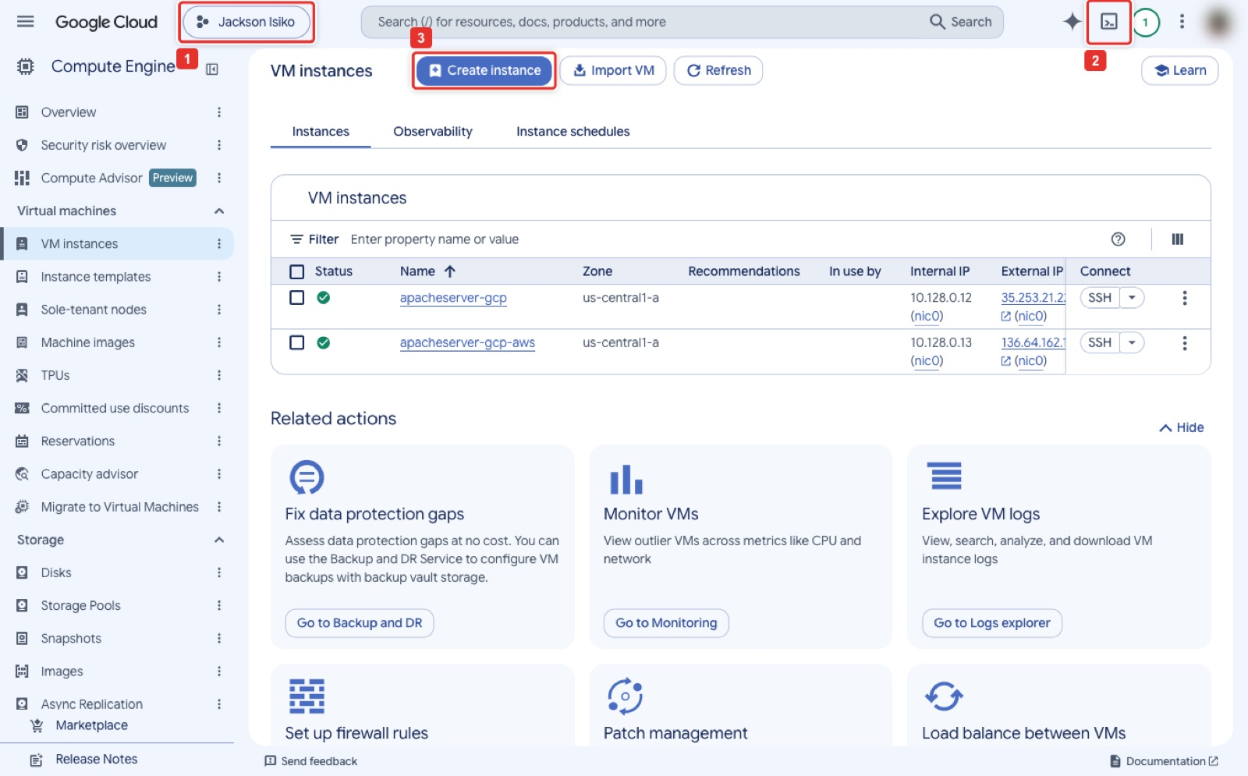
Figure 14. Project selector (1), the Activate Cloud Shell icon (2), and the Create instance button (3) used in Step 15.
What you see: The Compute Engine → VM instances page of the Google Cloud console. The project selector (1) in the top bar shows which project you are working in, and the >_ icon (2) opens Cloud Shell as a terminal at the bottom of the page. Create instance (3) is the button you will use in Step 15. The two VMs listed are from the instructor's earlier runs.
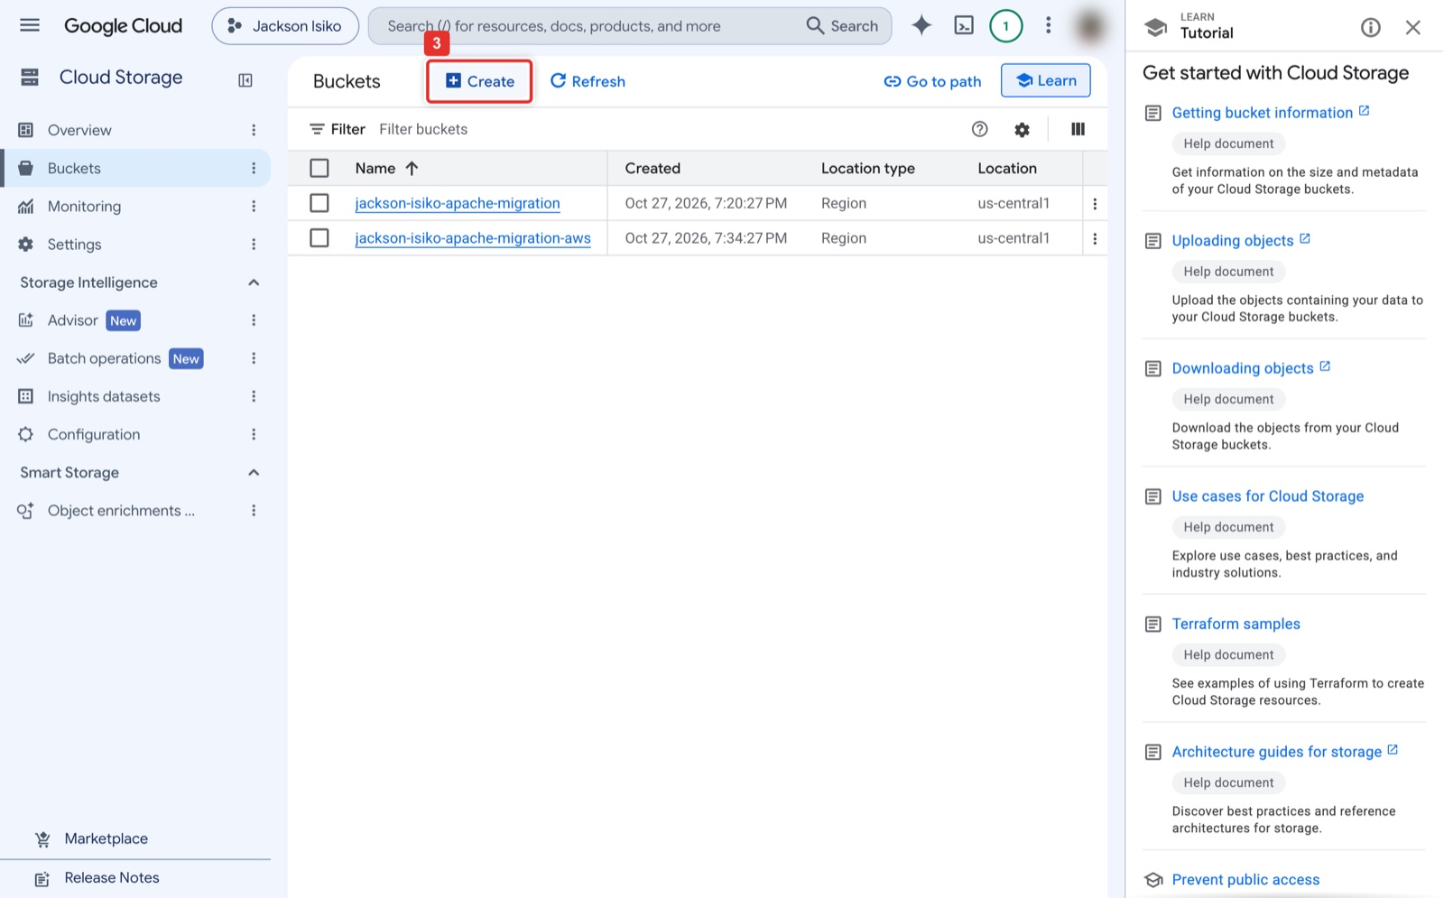
Figure 15. Cloud Storage → Buckets → Create bucket.
What you see: Cloud Storage → Buckets. Create (3) opens the bucket form. The instructor's project already lists two buckets from earlier runs; yours will be empty. The Learn panel on the right can be closed with its X.
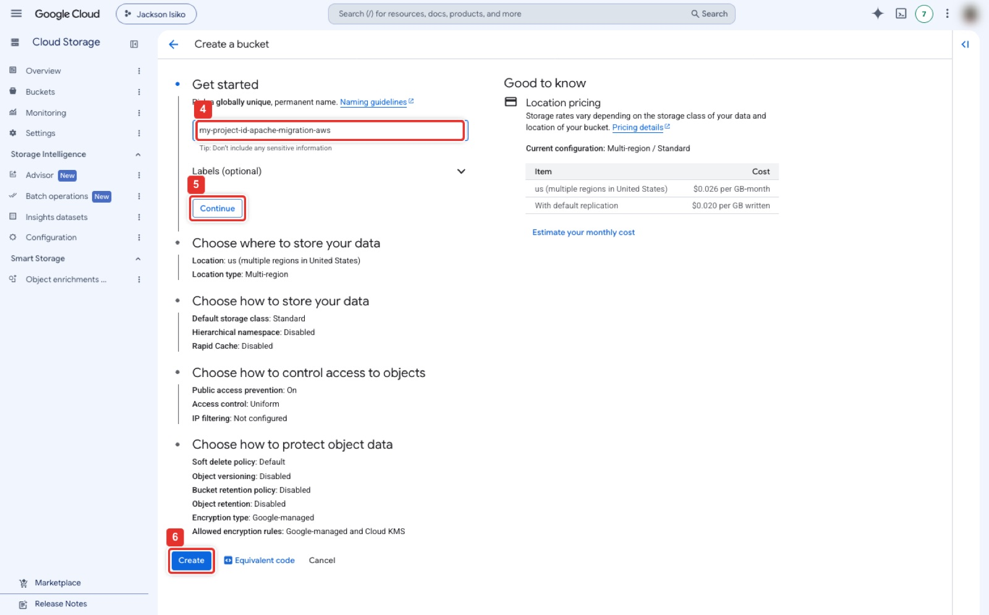
Figure 16. Name the bucket, Continue through the defaults (Region us-central1), Create.
What you see: The Create a bucket form, shown at a smaller zoom so the whole form fits. Type the bucket name in Name your bucket (4); it must be unique across Google Cloud and all lowercase. Click Continue (5) to move to the storage location, then through the remaining sections with their defaults (Standard class, uniform access, public access prevention on), and Create (6) at the bottom.
Google Cloud Shell
gcloud config set project <PROJECT_ID>
gcloud services enable compute.googleapis.com storage.googleapis.com
B=<PROJECT_ID>-apache-migration-aws
gcloud storage buckets create gs://$B --location=us-central1 --uniform-bucket-level-access

Step 10. Download the image into Cloud Shell and verify it
Google Cloud Shell (resumable; 1 to 10 minutes)
mkdir -p ~/lab1-import-aws && cd ~/lab1-import-aws
curl -f --retry 10 --retry-all-errors --retry-delay 5 -C - -O http://<EC2_PUBLIC_IP>/disk.qcow2
ls -l disk.qcow2
md5sum disk.qcow2 # must match the md5 from Step 7

Expected result
The same md5 as Checkpoint 2. If curl prints 404, the symlink from Step 8 is missing or the IP is wrong. If the download stalls, run the same curl line again; -C - resumes where it stopped.

Step 11. Remove the public download link in AWS
Console: where to click
Go back to the SSH session on the EC2 instance and delete the link (command below). There is no console button for this: the link is a file on the server. Leave the HTTP rule in place, because the AWS page is the "before" half of your screenshots and the verify script still expects it to answer.
The security group editor in the next two figures is where you change the SSH source when your IP changes: EC2 → Security Groups → apacheserver1-sg, the Inbound rules tab (1), Edit inbound rules (2), type the new address in the SSH row's Source (3), or Add rule (5) for a temporary CloudShell SSH rule, then Save rules (6). Do not press Delete (4) on the HTTP row.

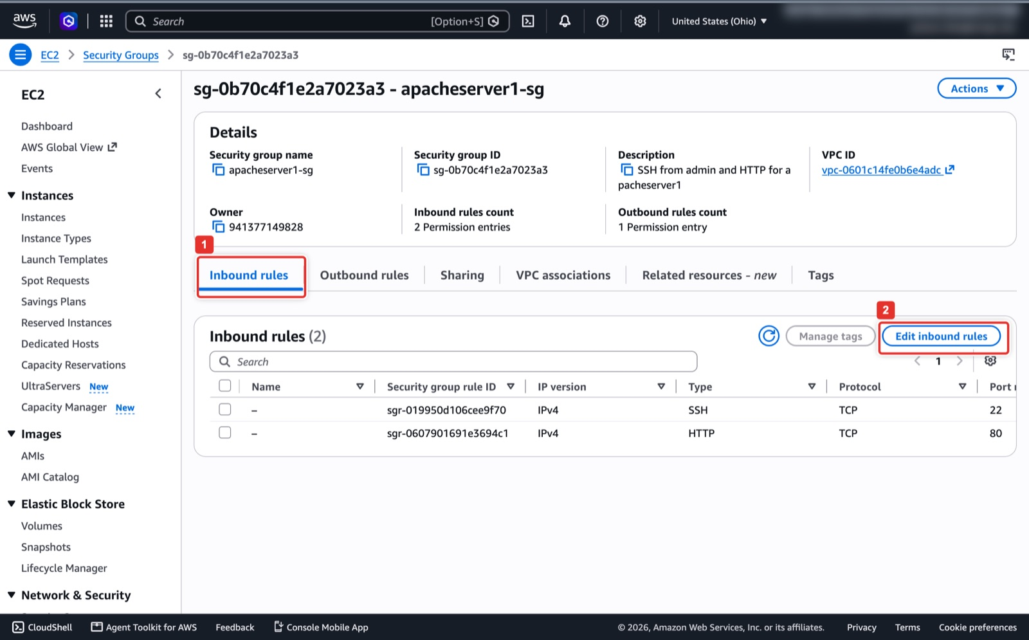
Figure 17. Security group → Inbound rules → Edit inbound rules.
What you see: The security group's detail page in EC2 → Security Groups. The Inbound rules tab (1) lists the two rules created with the instance: SSH on TCP 22 and HTTP on TCP 80. Edit inbound rules (2) opens the editor in the next figure.
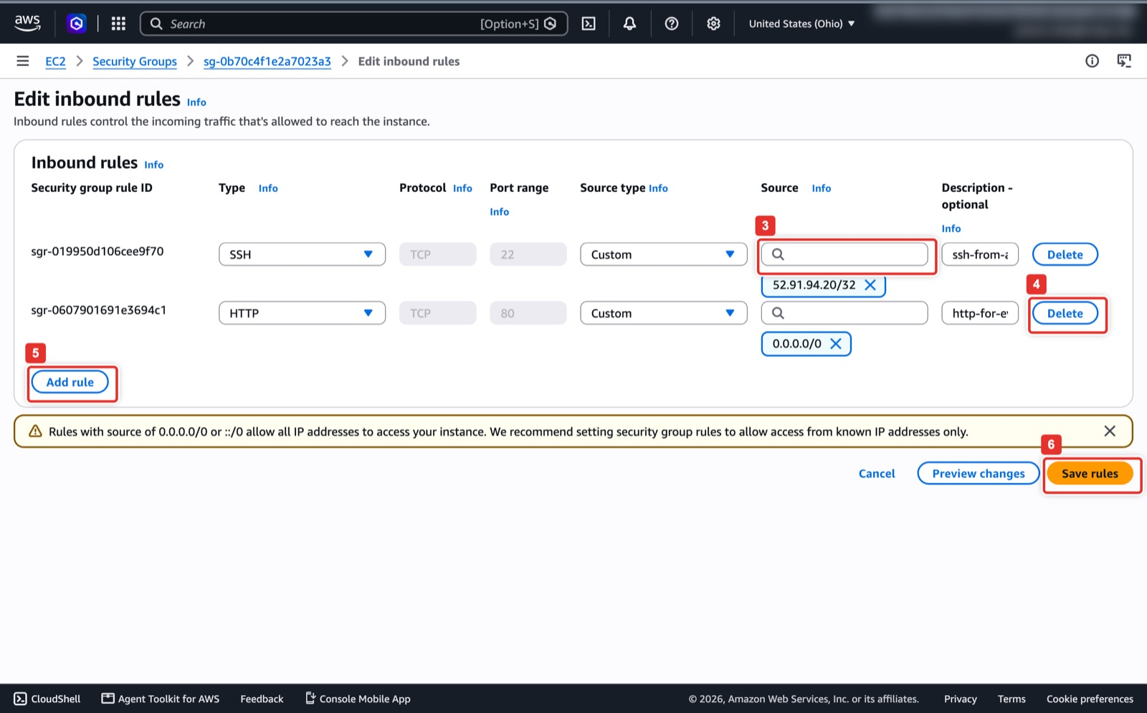
Figure 18. The rule editor: SSH source, Delete on the HTTP rule, Add rule, Save rules.
What you see: The Edit inbound rules editor. Each row is one rule. The SSH row's Source box (3) holds your address as a /32; type a new one when your IP changes. Delete (4) on the HTTP row would remove port 80; leave it, because Step 11 removes only the download link and the AWS page must keep answering. Add rule (5) adds a row, for example a temporary SSH rule for CloudShell. Nothing is applied until you click Save rules (6).
On the EC2 instance (SSH session)
sudo rm /var/www/html/disk.qcow2
curl -sI http://localhost/disk.qcow2 | head -1 # HTTP/1.1 404 Not Found

Step 12. Convert to the Compute Engine raw format
Compute Engine builds an image from a tar.gz that contains one file named `disk.raw`, written by GNU tar in oldgnu format with sparse-file support. Cloud Shell has the right tar.
Google Cloud Shell (2 to 4 minutes)
sudo apt-get install -y qemu-utils
qemu-img convert -O raw disk.qcow2 disk.raw && rm disk.qcow2
tar --format=oldgnu -Sczf disk.tar.gz disk.raw && rm disk.raw
ls -lh disk.tar.gz # about 1 GB

Note
Cloud Shell gives you 5 GB of home directory. The qcow2 (1 GB), the raw file (8 GB sparse, about 2 GB real) and the tar.gz (1 GB) fit because each command deletes its input. Do not keep more than one copy.

Step 13. Upload to Cloud Storage
Google Cloud Shell
gcloud storage cp disk.tar.gz gs://$B/disk.tar.gz
gcloud storage ls -l gs://$B/

Step 14. Create the Compute Engine image
Console: where to click
Compute Engine → Storage → Images → Create image (1). Name apacheserver-image-aws (2). Source: Cloud Storage file (3), click Browse and pick <PROJECT_ID>-apache-migration-aws/disk.tar.gz (4). Family apacheserver-aws (optional). Click Create (5). The image shows a spinner for 1 to 3 minutes, then a green tick.

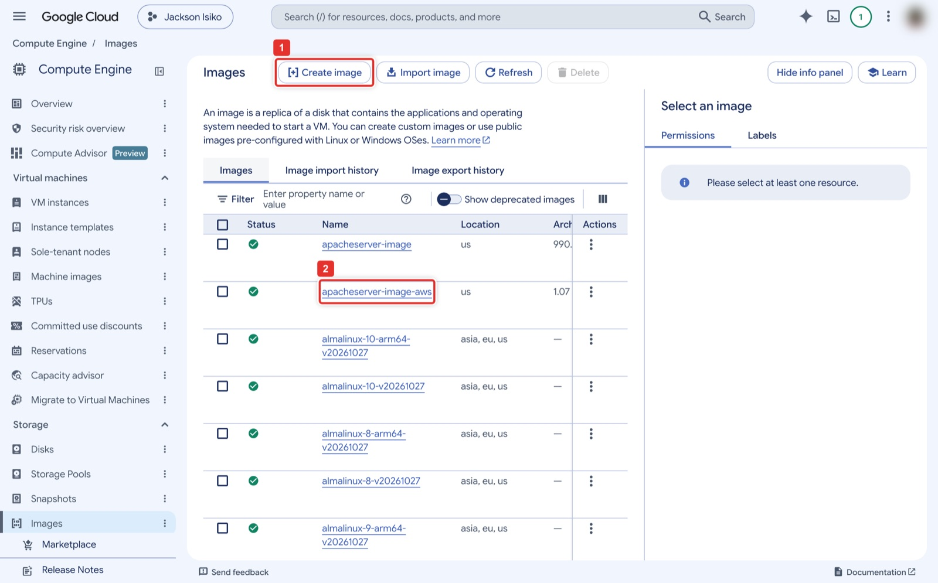
Figure 19. Compute Engine → Images → Create image; a finished image shows a green tick.
What you see: Compute Engine → Storage → Images. Create image (1) opens the form. Custom images appear at the top of the list with a green tick once they are ready; (2) points at the image from the instructor's run, apacheserver-image-aws, which is the name you will see after Step 14 completes. Public images (almalinux, debian, ...) follow further down.
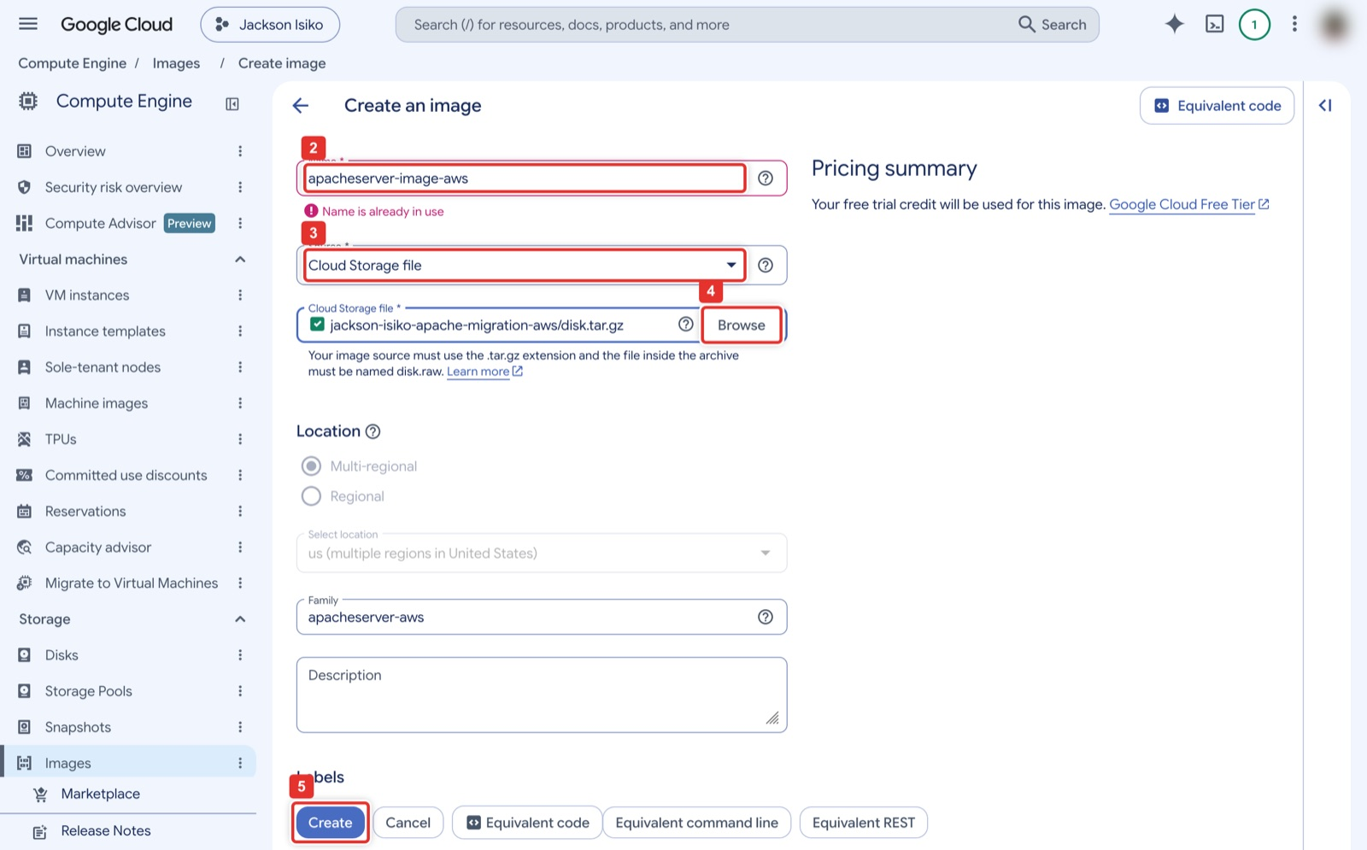
Figure 20. Create image: name, Source = Cloud Storage file, Browse to disk.tar.gz, Create.
What you see: The Create an image form. Name (2) is apacheserver-image-aws ("Name is already in use" shows only because the instructor's project already had it). Source (3) must be Cloud Storage file, and Browse (4) opens a picker where you choose your bucket and then disk.tar.gz; the note underneath reminds you that the archive must contain a file named disk.raw. Family is optional. Create (5) is at the bottom.
Google Cloud Shell (1 to 3 minutes)
gcloud compute images create apacheserver-image-aws \
--source-uri=gs://$B/disk.tar.gz --family=apacheserver-aws \
--description="Migrated from AWS apacheserver1"
gcloud compute images describe apacheserver-image-aws --format="value(name,status,diskSizeGb)"

Expected result
apacheserver-image-aws, READY and 8, separated by tabs. If the create command returns a read timeout after 300 seconds, the image is still being built: run the describe line until the status is READY.

Step 15. Launch the VM from the image
Console: where to click
Compute Engine → VM instances → Create instance (the button marked 3 in Figure 14). Name apacheserver-gcp-aws (2), Region us-central1, Zone us-central1-a (3), Machine type e2-micro (4).
In the left column open OS and storage (5) and click Change on the boot disk (6). Open the Custom images tab (7), choose apacheserver-image-aws (8), keep size 10 GB (9), click Select (10).
Open Networking (11) and tick Allow HTTP traffic (12), which adds the http-server network tag (13). Click Create (14). The VM shows a green tick within a minute and an External IP in the list.

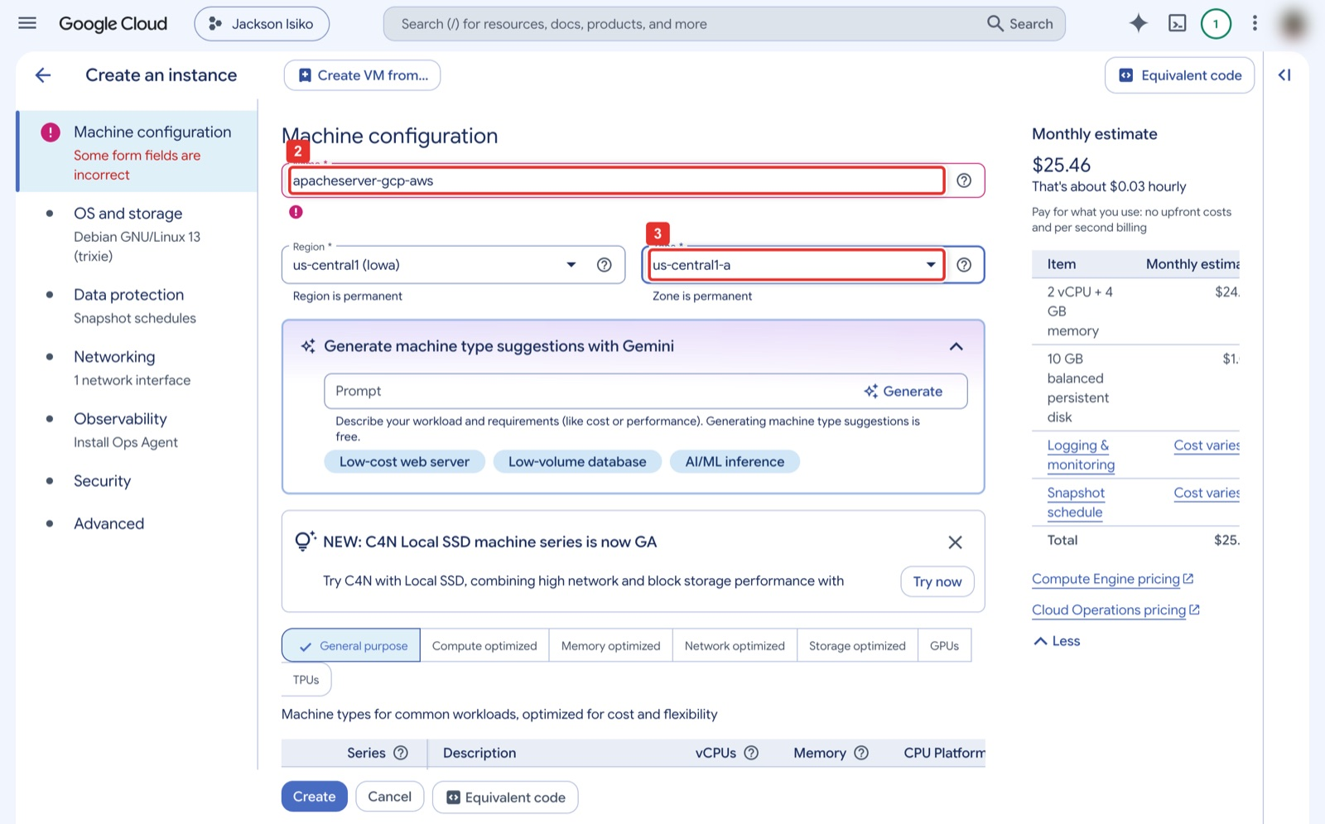
Figure 21. Create instance: name and zone us-central1-a.
What you see: The first page of Create an instance, Machine configuration. Name (2) is apacheserver-gcp-aws; the red outline and "Some form fields are incorrect" appear only because that name already existed in the instructor's project. Region stays us-central1 (Iowa) and Zone (3) is us-central1-a. The Monthly estimate on the right starts at the default machine size and falls once you pick e2-micro.
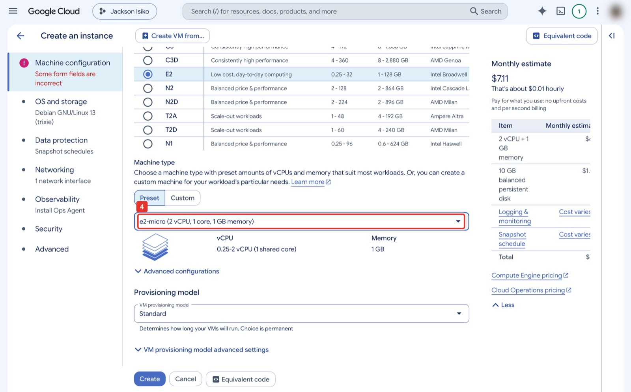
Figure 22. Machine type e2-micro (E2 series, Preset).
What you see: Lower on the same page. In the series table E2 is selected (low cost, day-to-day computing). Under Machine type keep Preset and choose e2-micro (4) from the dropdown; the panel confirms 0.25-2 vCPU (1 shared core) and 1 GB memory, and the estimate drops to about 7 dollars a month.
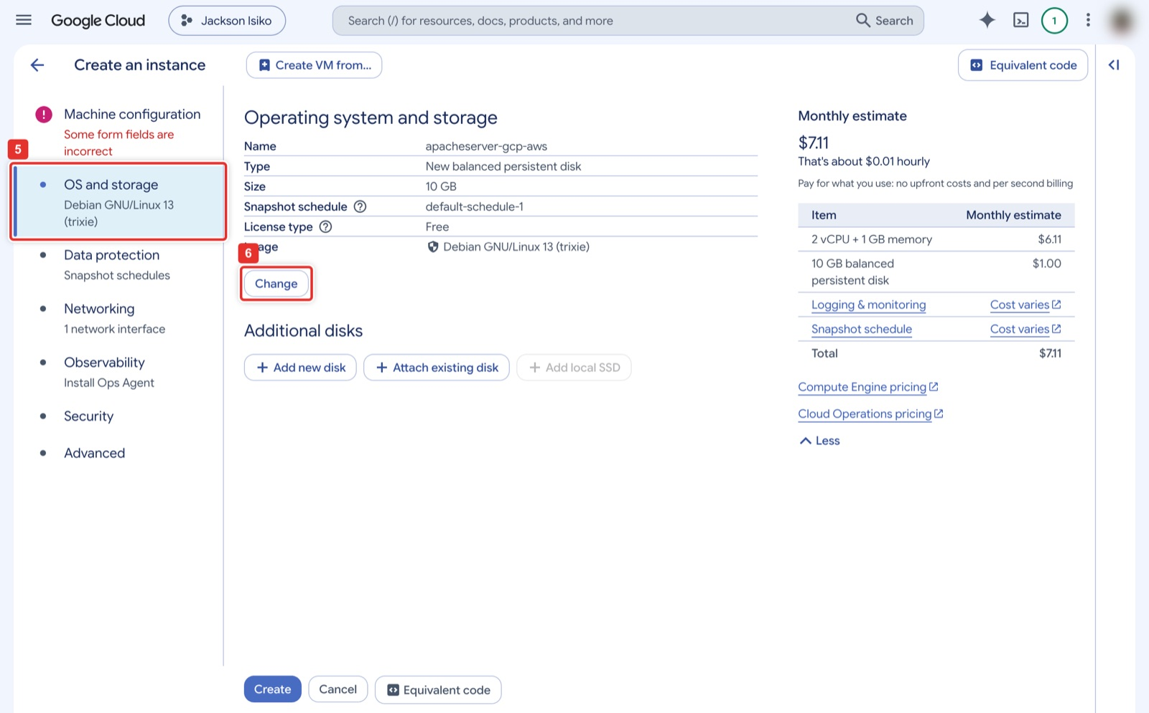
Figure 23. OS and storage step → Change on the boot disk.
What you see: The OS and storage step (5) in the left column. The boot disk still shows the default Debian GNU/Linux image, 10 GB; click Change (6) to replace it with your custom image. Leave Additional disks empty.
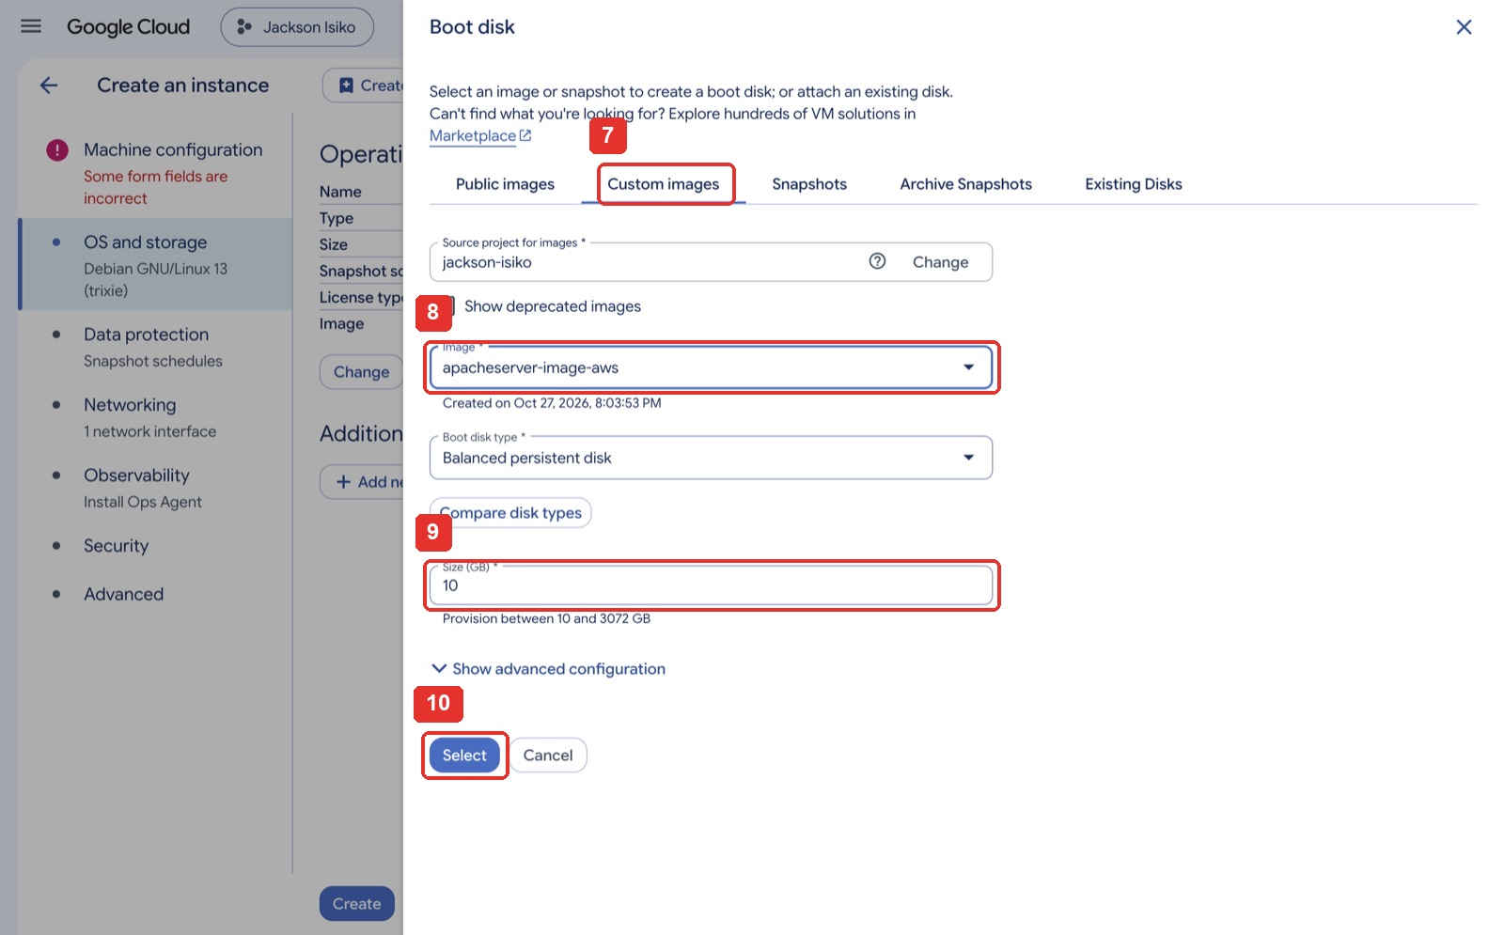
Figure 24. Boot disk panel: Custom images tab, the image, its size, and Select.
What you see: The Boot disk side panel. Open the Custom images tab (7); Source project for images is your own project. Pick apacheserver-image-aws from Image (8); the creation date under it confirms it is the image from Step 14. Size (GB) (9) is 10 and cannot be smaller than the image. Click Select (10) to close the panel; the OS and storage summary then names your image.
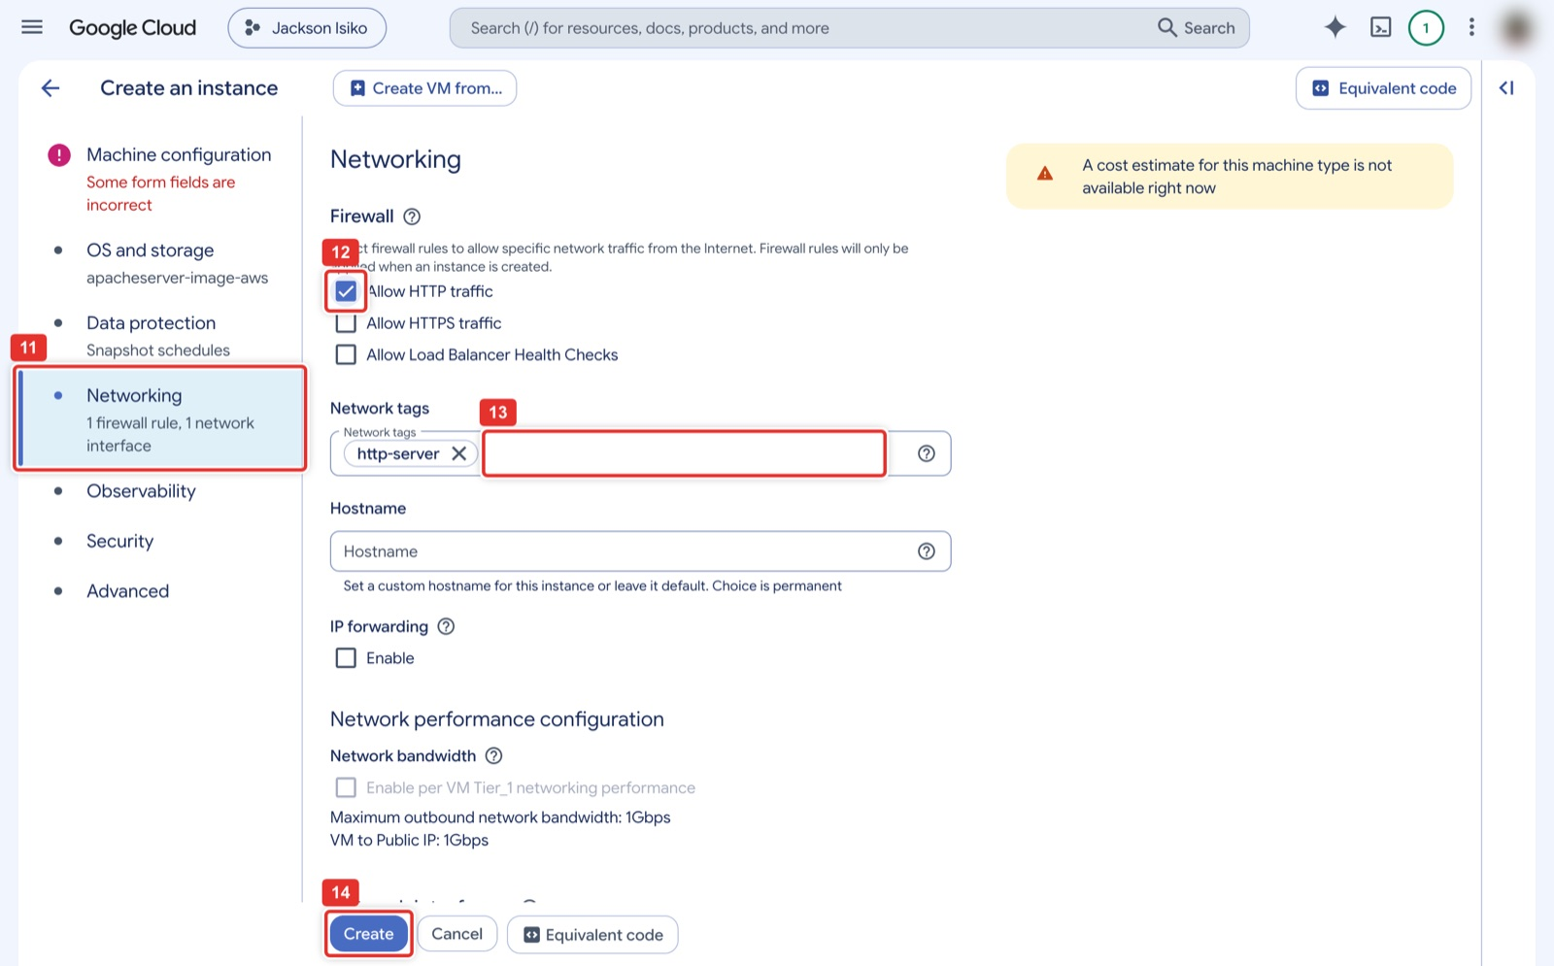
Figure 25. Networking step → Allow HTTP traffic (adds the http-server tag) → Create.
What you see: The Networking step (11). Under Firewall tick Allow HTTP traffic (12); the Network tags field (13) then shows the http-server tag, which is what the firewall rule in Step 16 matches. HTTPS and load balancer health checks stay off. Create (14) at the bottom builds the VM; it appears in the list with a green tick in under a minute.
Google Cloud Shell
gcloud compute instances create apacheserver-gcp-aws \
--zone=us-central1-a --machine-type=e2-micro \
--image=apacheserver-image-aws --boot-disk-size=10GB --tags=http-server

Expected result
A one-line table with STATUS RUNNING and an EXTERNAL_IP. Write the IP down.

Step 16. Open HTTP in the VPC firewall
Ticking Allow HTTP traffic in Step 15 only tags the VM; the rule that matches the tag must exist. Ticking Allow HTTP traffic in the console creates default-allow-http if it is missing; gcloud compute instances create --tags=http-server does not, so after a command-line Step 15 create allow-http.
Console: where to click
VPC network → Firewall → Create firewall rule (1, the button above the rule list). Name allow-http (2), Network default (3), Direction Ingress (4), Action Allow. Targets Specified target tags and type http-server (5). Source IPv4 ranges 0.0.0.0/0 (6). Protocols and ports: tick TCP and type 80 (7). Create (8).

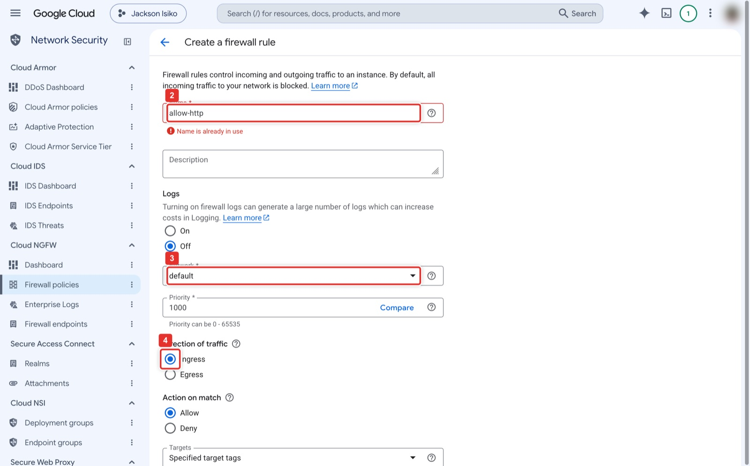
Figure 26. Create firewall rule: name, network default, direction Ingress.
What you see: The top of Create a firewall rule (the console files it under Network Security → Cloud NGFW → Firewall policies). Name (2) is allow-http; the warning shows only because the instructor's project already has that rule. Logs stays Off, Network (3) is default, Priority 1000, and Direction of traffic (4) is Ingress with Action on match Allow.
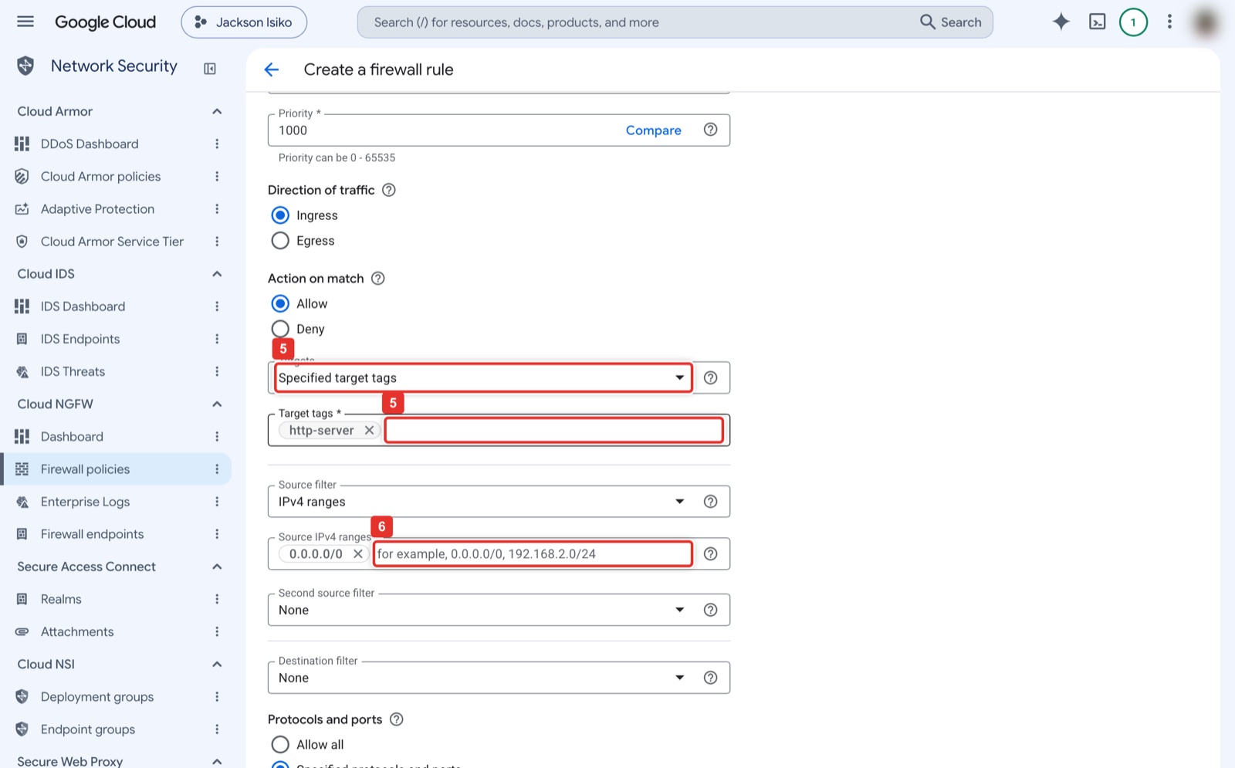
Figure 27. Targets = Specified target tags with http-server, source range 0.0.0.0/0.
What you see: The middle of the same form. Targets (5) is Specified target tags, and the Target tags field beneath it holds http-server (press Enter after typing so it becomes a chip). Source filter is IPv4 ranges and Source IPv4 ranges (6) holds 0.0.0.0/0, again as a chip. Second source filter and Destination filter stay None.
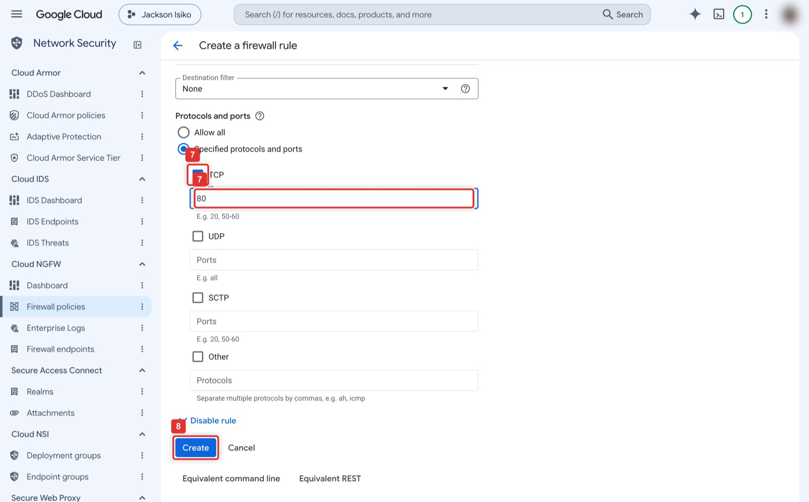
Figure 28. TCP port 80, then Create.
What you see: The bottom of the form. Under Protocols and ports choose Specified protocols and ports, tick TCP (7) and type 80 in its Ports box. Leave UDP, SCTP and Other unticked. Create (8) saves the rule, which takes effect within seconds.
Google Cloud Shell
gcloud compute firewall-rules create allow-http --network=default \
--direction=INGRESS --action=ALLOW --rules=tcp:80 \
--source-ranges=0.0.0.0/0 --target-tags=http-server

Note
In the Vocareum GCP lab this fails with Required 'compute.networks.updatePolicy' permission. Use your personal project, or rely on the project's existing default-allow-http rule, which already targets the http-server tag.

Part C-alt. Two other ways to move the image: AWS export and Google Migrate to VMs (optional)
Parts B and C copy the disk yourself, which works on every account. The two routes below use the providers' own migration tools instead. Both need AWS permissions that the Vocareum sandbox denies (it deletes export tasks and refuses to create IAM users), so use them on a personal AWS account, or watch the instructor do them. Whichever route you take, finish with Part D.
Route | What moves | Needs in AWS | Needs in GCP
A. Disk copy (Parts B and C) | disk.qcow2 over HTTP | SSH to the instance | Cloud Storage, Create image
B. AMI export + Image Import | AMI → VMDK in S3 → Cloud Storage | vmimport role, S3 bucket, export-image | Migrate to VMs → Image imports
C. Migrate to VMs AWS connector | Snapshots pulled by Google | IAM user with an access key | Migrate to VMs → Sources → AWS

Route B. Export an AMI with AWS tools, import it with Google Image Import

B1. Create an AMI of the instance
Console: where to click
EC2 → Instances: tick apacheserver1 (1), Actions (2) → Image and templates (3) → Create image (4).
Image name apacheserver1-ami (5). Keep Reboot instance ticked (6) so the copy is consistent. Click Create image (7). Open Images → AMIs (8), filter Owned by me, and wait for the status Available (2 to 5 minutes).

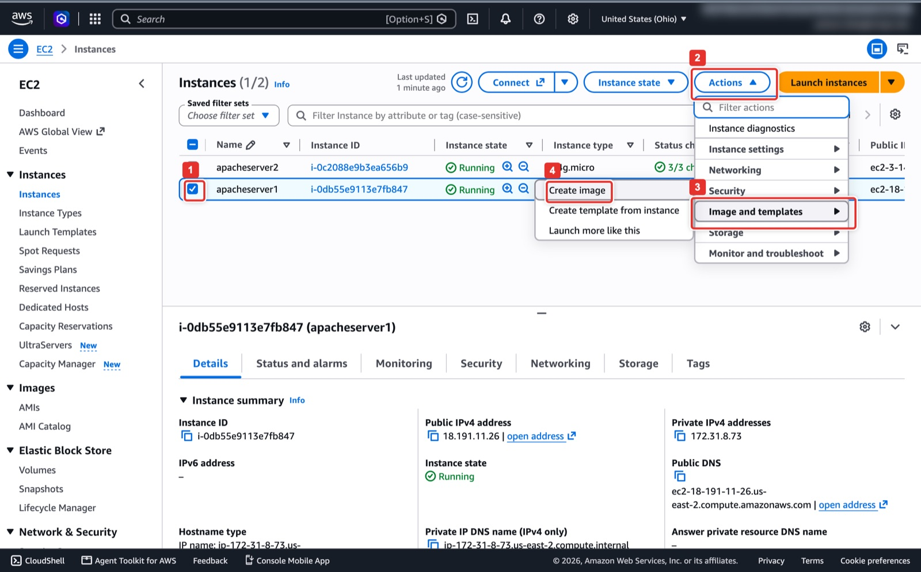
Figure 29. Actions → Image and templates → Create image.
What you see: EC2 → Instances with apacheserver1 ticked (1). Actions (2) opens the instance menu; Image and templates (3) opens a submenu whose first item is Create image (4). The instructor's account also shows a second instance, apacheserver2, which belongs to another user and is not part of this lab.
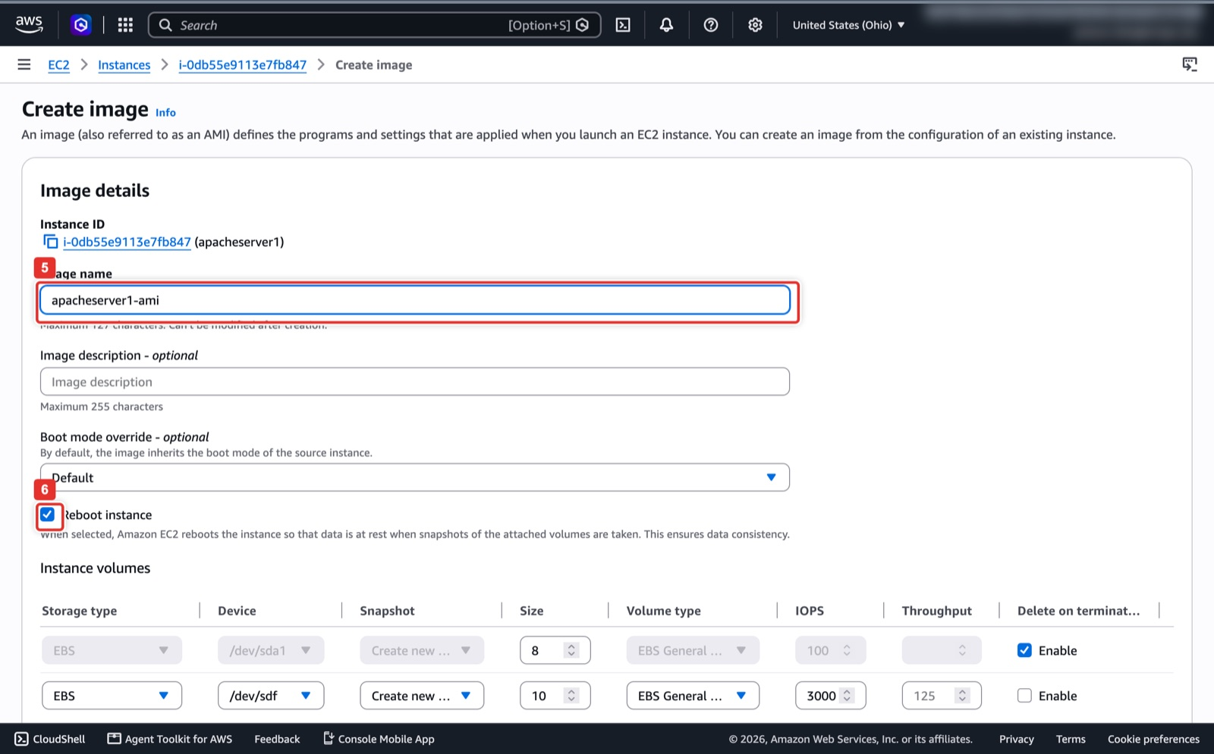
Figure 30. Create image: name and Reboot instance.
What you see: The Create image page. Image name (5) is apacheserver1-ami; description and boot mode can stay empty and Default. Keep Reboot instance (6) ticked so AWS pauses writes while it snapshots the disks. The Instance volumes table lists both the 8 GiB root disk and the 10 GiB scratch volume; if you want only the root disk in the AMI, remove the /dev/sdf row before creating.
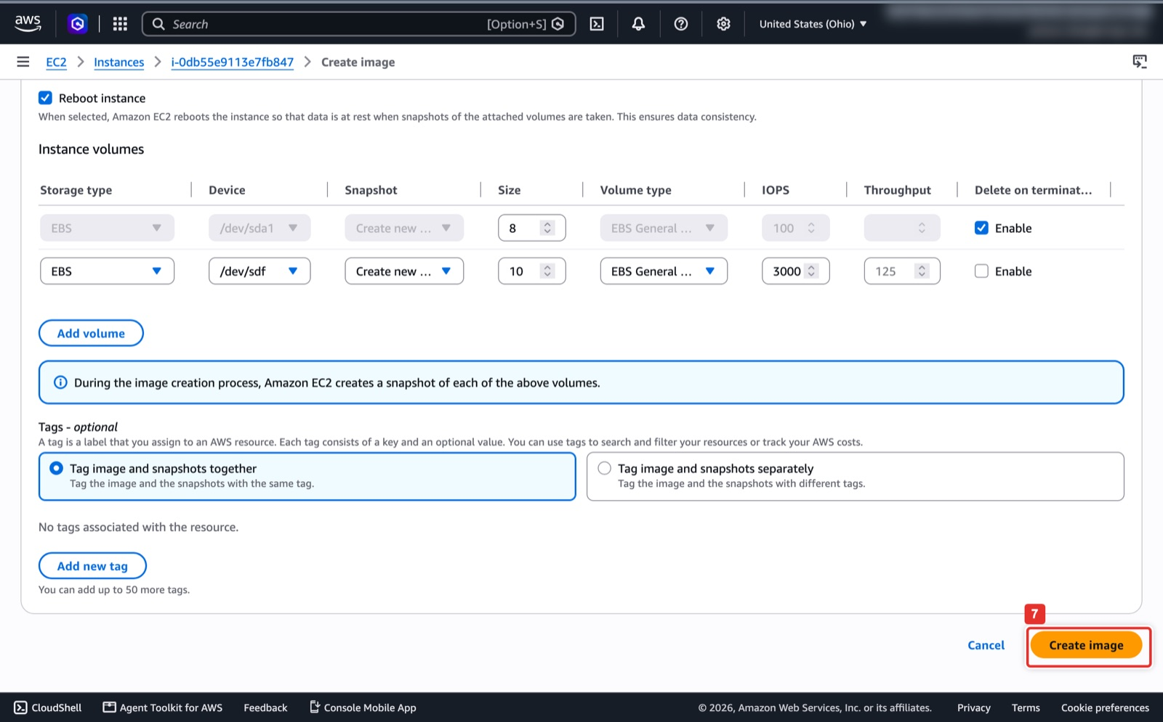
Figure 31. Create image button at the bottom of the form.
What you see: The bottom of the same page. Tags are optional, and Create image (7) starts the snapshot. The AMI then appears under Images → AMIs with status Pending.
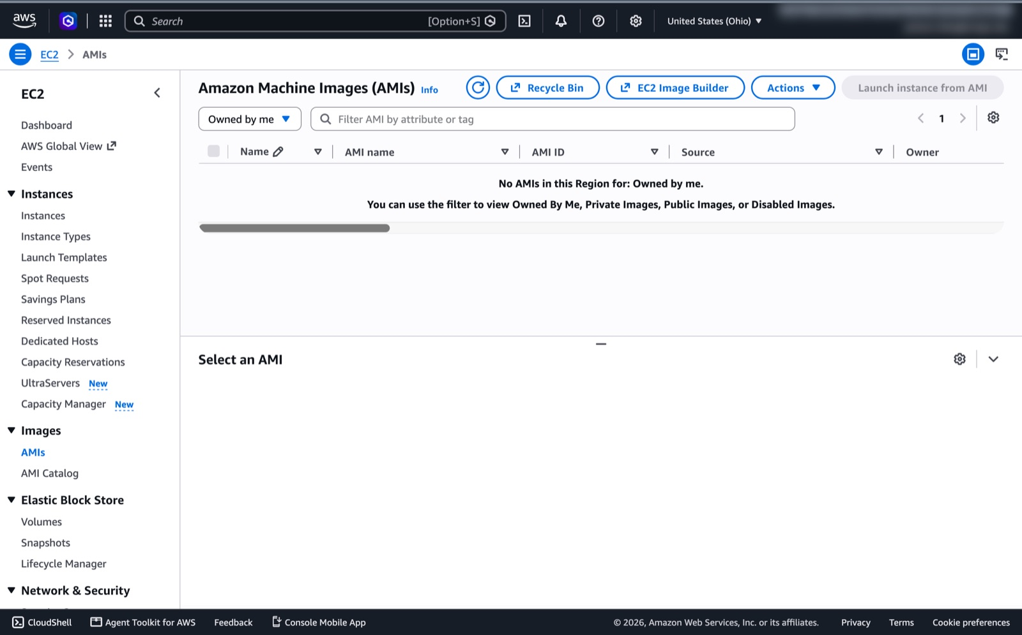
Figure 32. AMIs → Owned by me is where the new image and its status appear (empty in this screenshot).
What you see: Images → AMIs with the filter set to Owned by me. The list is empty here because no image was created while taking the screenshots. After B1 your list shows apacheserver1-ami with its AMI ID and a status that reads Pending first and Available after 2 to 5 minutes. Wait for Available before running export-image.
AWS CloudShell
export AWS_DEFAULT_REGION=us-east-2
I=<INSTANCE_ID>
AMI=$(aws ec2 create-image --instance-id $I --name apacheserver1-ami --query ImageId --output text)
aws ec2 wait image-available --image-ids $AMI; echo $AMI

B2. One-time setup: an S3 bucket and the vmimport role
The export service writes into your bucket through an IAM role that must be named exactly vmimport and trust vmie.amazonaws.com. There is no console wizard for this; use CloudShell.
AWS CloudShell
B=apacheserver1-export-$(aws sts get-caller-identity --query Account --output text)
aws s3 mb s3://$B --region us-east-2
cat > trust.json <<'EOF'
{"Version":"2012-10-17","Statement":[{"Effect":"Allow","Principal":{"Service":"vmie.amazonaws.com"},
"Action":"sts:AssumeRole","Condition":{"StringEquals":{"sts:Externalid":"vmimport"}}}]}
EOF
cat > role-policy.json <<EOF
{"Version":"2012-10-17","Statement":[
{"Effect":"Allow","Action":["s3:GetBucketLocation","s3:GetObject","s3:ListBucket","s3:PutObject","s3:GetBucketAcl"],
"Resource":["arn:aws:s3:::$B","arn:aws:s3:::$B/*"]},
{"Effect":"Allow","Action":["ec2:ModifySnapshotAttribute","ec2:CopySnapshot","ec2:RegisterImage","ec2:Describe*"],"Resource":"*"}]}
EOF
aws iam create-role --role-name vmimport --assume-role-policy-document file://trust.json
aws iam put-role-policy --role-name vmimport --policy-name vmimport --policy-document file://role-policy.json

B3. Export the AMI as a VMDK (CLI only)
AWS CloudShell (10 to 30 minutes)
TASK=$(aws ec2 export-image --image-id $AMI --disk-image-format VMDK \
--s3-export-location S3Bucket=$B,S3Prefix=export/ --query ExportImageTaskId --output text)
aws ec2 describe-export-image-tasks --export-image-task-ids $TASK \
--query 'ExportImageTasks[0].[Status,Progress,StatusMessage]' --output text # repeat until: completed
aws s3 ls s3://$B/export/ # export-ami-....vmdk, about 1.5 GB

Watch out
On the Vocareum sandbox the task shows deleted within seconds. That is the sandbox policy, not your mistake; use Route A there.

B4. Move the VMDK to Cloud Storage
Cloud Shell has no AWS credentials. Hand it a pre-signed URL (valid one hour) instead of keys.
AWS CloudShell, then Google Cloud Shell
# AWS CloudShell: print a one-hour download link
aws s3 presign s3://$B/export/<FILE>.vmdk --expires-in 3600
# Google Cloud Shell: fetch it and put it in your bucket
curl -f -L -o disk.vmdk "<PRESIGNED_URL>"
gcloud storage cp disk.vmdk gs://<PROJECT_ID>-apache-migration-aws/disk.vmdk

B5. Import the VMDK as a Compute Engine image
Console: where to click
If you open Compute Engine → Images → Create image and choose Source Virtual disk (VMDK, VHD) (2), the console tells you that Image Import has moved; click Go to new Image Import (3).
That opens Migrate to Virtual Machines → Image imports → Import image. Name apacheserver-image-aws-vmdk (4), Source Cloud Storage file <PROJECT_ID>-apache-migration-aws/disk.vmdk (5), Region us-central1 (6). Leave Advanced (7) at its defaults (the import adapts the OS and installs the guest environment). Click Import (8). The import runs a temporary worker VM and takes 10 to 20 minutes; watch the Image imports tab until it reads Succeeded.

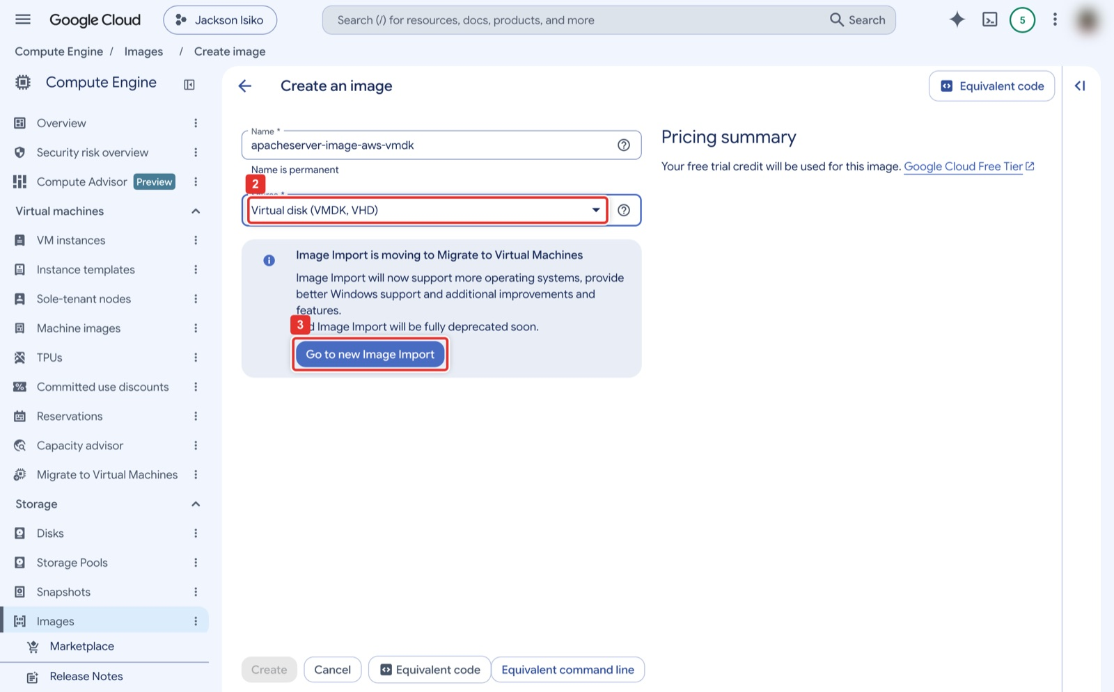
Figure 33. Create image with a Virtual disk source redirects to the new Image Import.
What you see: The classic Create an image form after choosing Source Virtual disk (VMDK, VHD) (2). Instead of showing file fields, the console displays the notice that Image Import is moving to Migrate to Virtual Machines and greys out Create. Go to new Image Import (3) takes you to the form in the next figure.
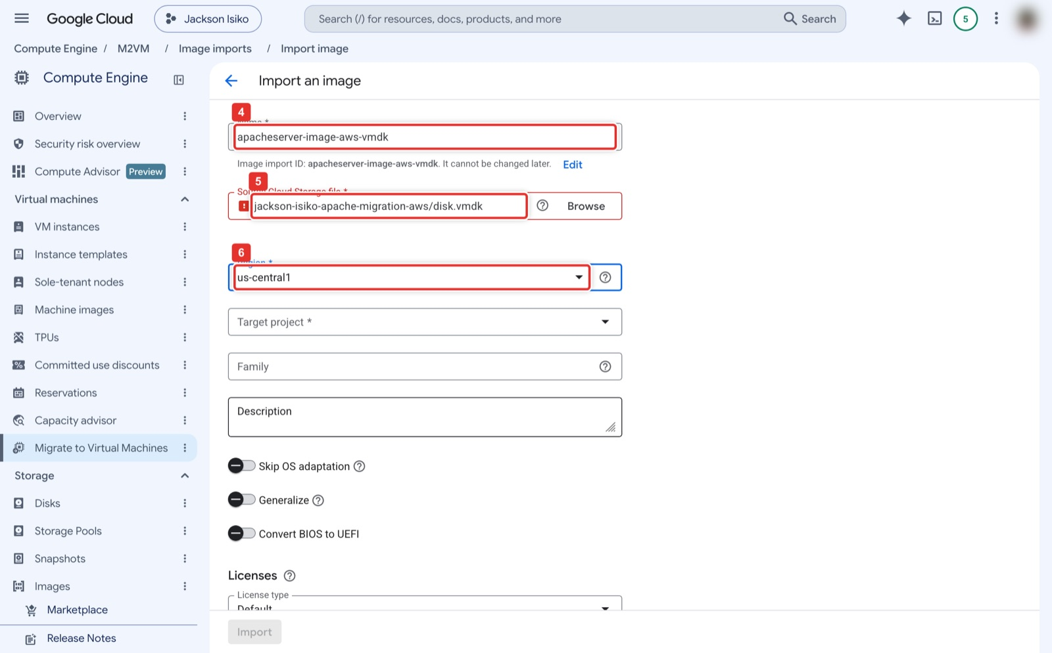
Figure 34. Import an image: name, Cloud Storage file, region.
What you see: The Import an image form under Migrate to Virtual Machines → Image imports. Name (4) is apacheserver-image-aws-vmdk (the Image import ID is derived from it). Source Cloud Storage file (5) is the bucket path to disk.vmdk, typed or chosen with Browse. Region (6) is us-central1. Target project defaults to the current project; Family and Description are optional. The toggles Skip OS adaptation, Generalize and Convert BIOS to UEFI stay off.
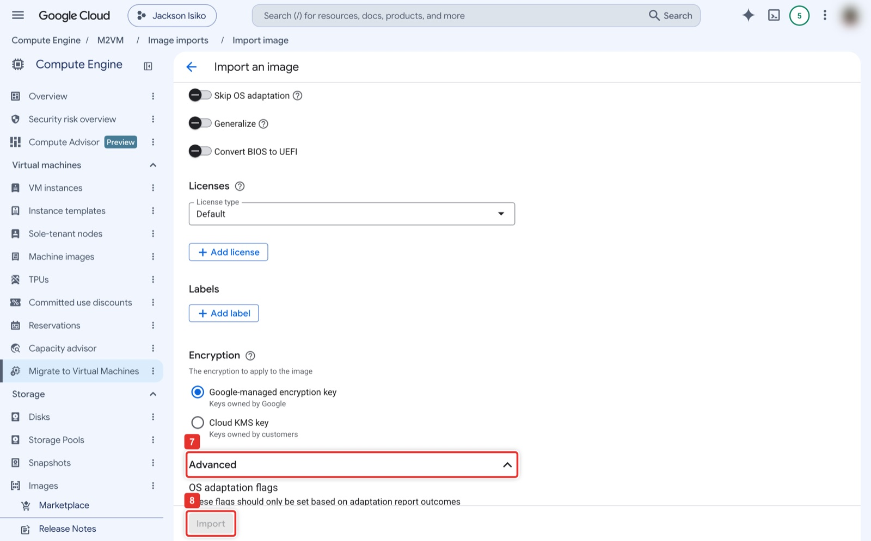
Figure 35. Advanced options and the Import button.
What you see: Lower on the same form: Licenses Default, no Labels, Google-managed encryption key. The Advanced section (7) holds OS adaptation flags that you only set when an import report asks for them. Import (8) at the bottom stays grey until every required field is valid; it starts the import, which runs a temporary worker VM for 10 to 20 minutes.
Google Cloud Shell
gcloud services enable vmmigration.googleapis.com
gcloud migration vms image-imports create apacheserver-image-aws-vmdk --location=us-central1 \
--source-file=gs://<PROJECT_ID>-apache-migration-aws/disk.vmdk \
--image-name=apacheserver-image-aws-vmdk # target project defaults to the current project
gcloud migration vms image-imports describe apacheserver-image-aws-vmdk --location=us-central1 # until SUCCEEDED
gcloud compute instances create apacheserver-gcp-aws --zone=us-central1-a --machine-type=e2-micro \
--image=apacheserver-image-aws-vmdk --boot-disk-size=10GB --tags=http-server

Expected result
A new image in Compute Engine → Images, and after the create command a running VM. Continue with Part D. Because the import installs the guest agent, gcloud compute ssh works right away.

Route C. Google Migrate to Virtual Machines with the AWS source connector
Google replicates the running EC2 instance from EBS snapshots; you copy nothing by hand. It needs an IAM user access key in AWS, which the Vocareum sandbox refuses to create.

C1. In AWS: an IAM user and access key for the connector
Console: where to click
IAM → Policies → Create policy → JSON: paste the policy from Google's Migrate to VMs: AWS prerequisites page (read access to EC2 plus snapshot create, delete and tag, and the EBS direct read actions ebs:ListSnapshotBlocks, ebs:GetSnapshotBlock, ebs:ListChangedBlocks). Name it migrate-to-vms.
IAM → Users → Create user m2vm-connector → Attach policies directly → migrate-to-vms. Then Security credentials → Create access key → Third-party service. Copy the Access key ID and Secret access key once; you paste them in C2 and never store them in a file or a repo.

C2. In GCP: add the AWS source
Console: where to click
Compute Engine → VM instances → Import VM (1) opens Migrate to Virtual Machines. Or go straight to Compute Engine → Migrate to Virtual Machines.
On the Sources tab (1) click Add source (2) → Add AWS source (5). Name aws-us-east-2 (6), GCP region us-central1 (7), AWS region us-east-2 (8), paste the Access key ID (9) and Secret access key (10), click Create (11). After a minute the source lists your EC2 inventory.

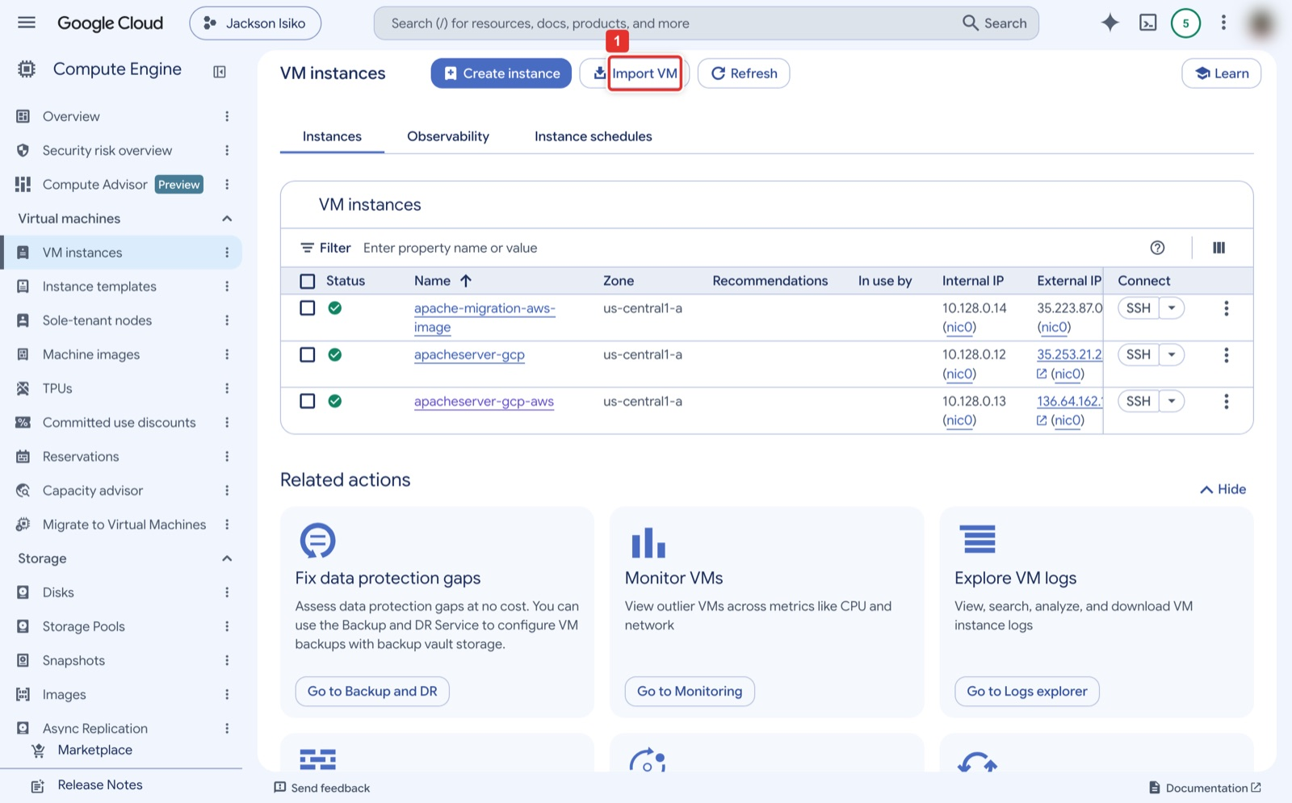
Figure 36. VM instances → Import VM is a shortcut into Migrate to Virtual Machines.
What you see: Compute Engine → VM instances. Next to Create instance there is an Import VM button (1), a shortcut to the Migrate to Virtual Machines pages used in Route C. The three VMs listed are from the instructor's runs.
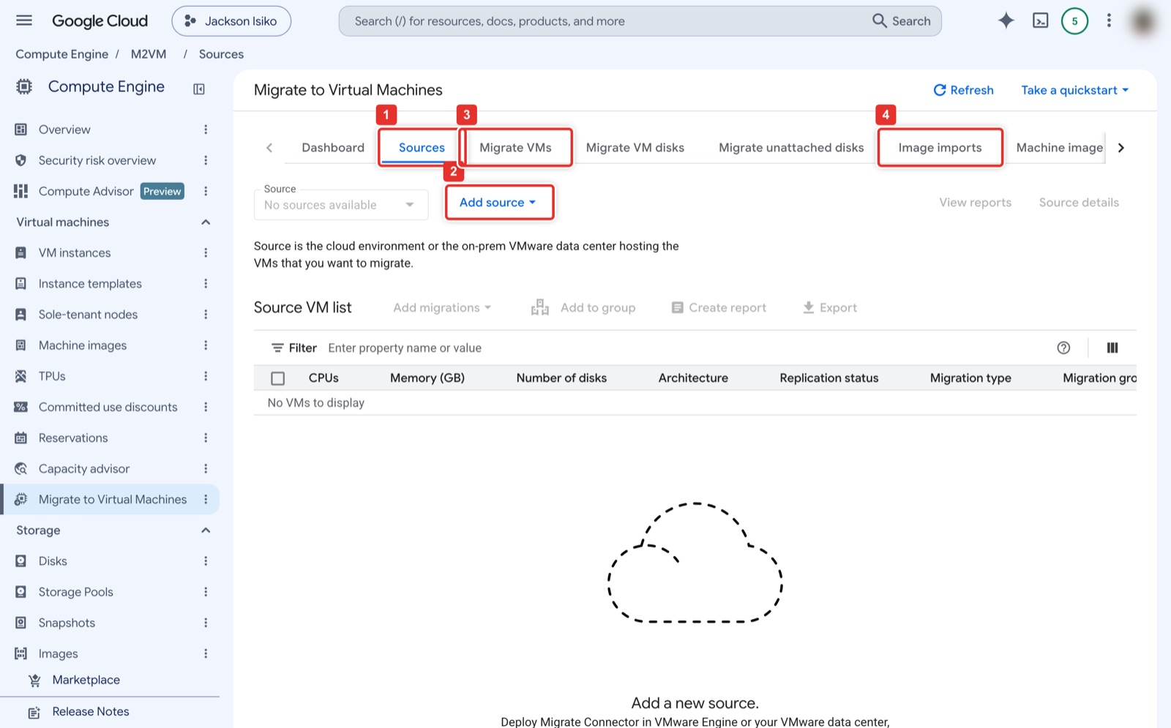
Figure 37. Migrate to Virtual Machines: Sources, Add source, and the Migrate VMs and Image imports tabs.
What you see: The Migrate to Virtual Machines overview. Its tabs across the top are Dashboard, Sources (1), Migrate VMs (3), Migrate VM disks, Migrate unattached disks, Image imports (4) and Machine image imports. On Sources, Add source (2) is the button for connecting a cloud account; the Source VM list underneath stays empty until a source has been added and its inventory has loaded.
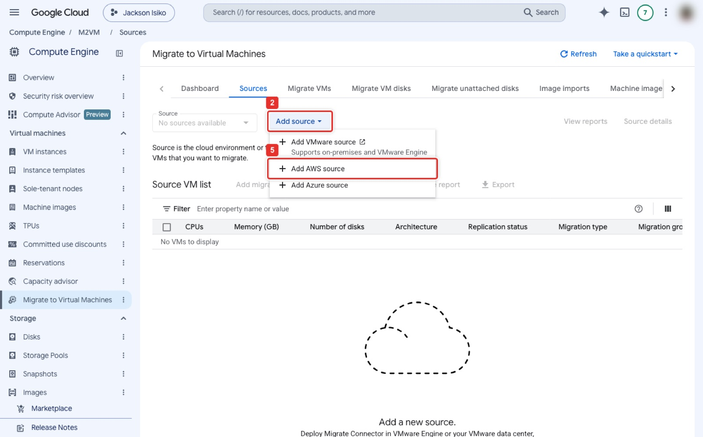
Figure 38. Add source → Add AWS source.
What you see: Add source (2) opens a three-item menu: Add VMware source, Add AWS source (5) and Add Azure source. Choose Add AWS source.
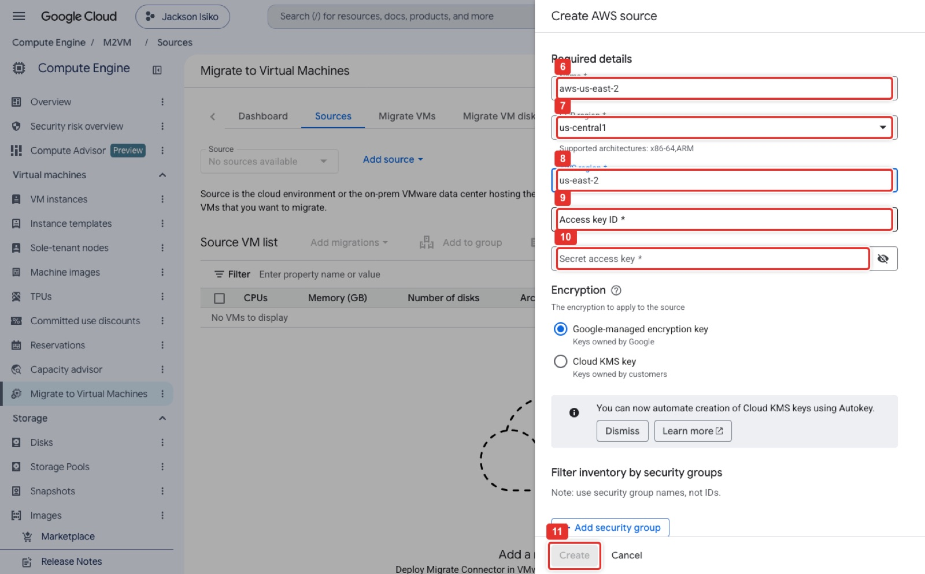
Figure 39. Create AWS source: name, GCP region, AWS region, access key ID and secret.
What you see: The Create AWS source side panel. Name (6) is aws-us-east-2, GCP region (7) is us-central1 (the dropdown lists the regions that support the connector), and AWS region (8) is us-east-2, picked from the autocomplete. Access key ID (9) and Secret access key (10) take the credentials of the IAM user from C1; the eye icon shows or hides the secret. Encryption stays Google-managed. Create (11) at the bottom turns blue once all five fields are filled.

C3. Replicate, set the target, cut over
Console: where to click
Open the source, tick apacheserver1 → Add migrations. On the Migrate VMs tab (1) select it → Start replication. The first cycle copies the whole 8 GB disk (10 to 30 minutes); later cycles copy only changed blocks.
Edit target details: project, zone us-central1-a, machine type e2-micro, network default, external IP Ephemeral, network tag http-server. Then Cut-over (or Test-clone to try without stopping replication). Google creates the Compute Engine VM from the latest snapshot and installs the guest environment.
When the VM answers on port 80 (Part D), click Finalize to release the replication resources. Delete the source when you are done.

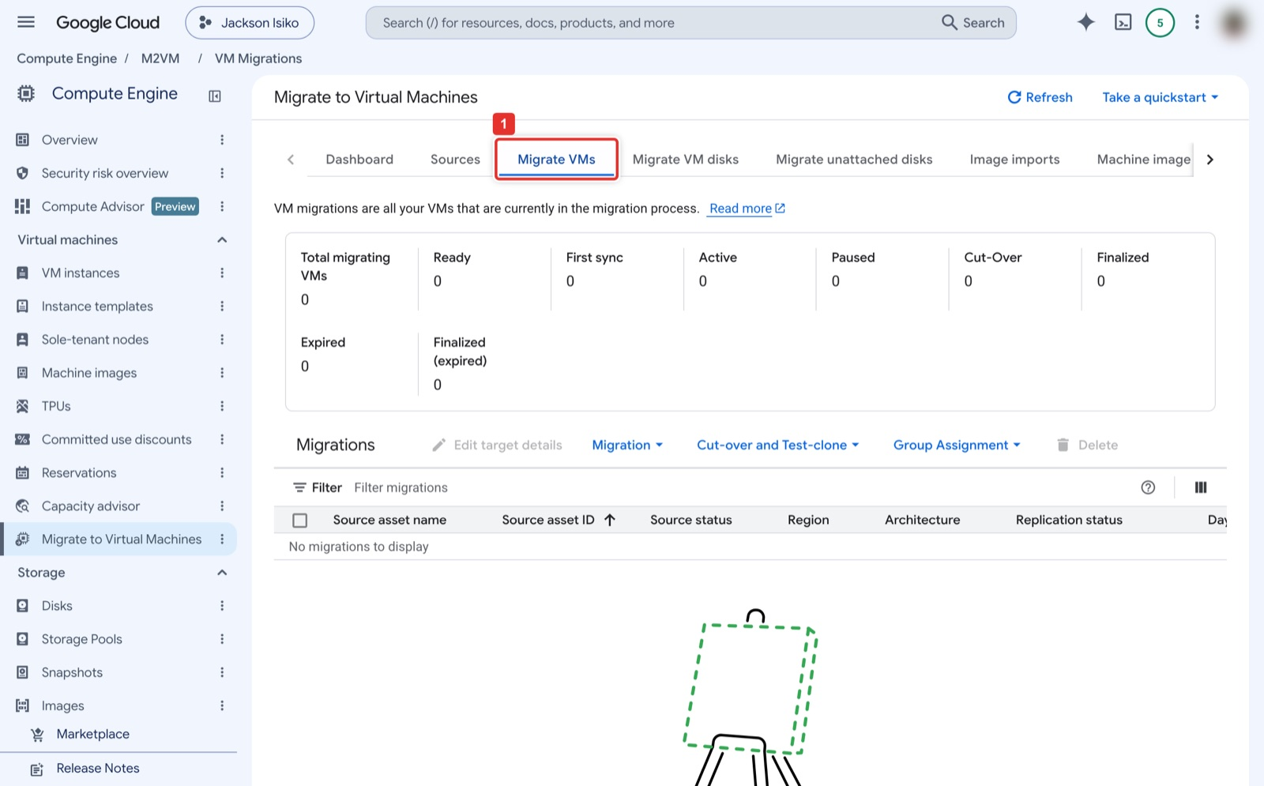
Figure 40. The Migrate VMs tab is where you start replication, edit target details, cut over and finalize.
What you see: The Migrate VMs tab (1). The counters across the top (Total migrating VMs, Ready, First sync, Active, Paused, Cut-Over, Finalized) show where each migration is in its cycle. The toolbar above the table holds Edit target details, the Migration menu (Start and Stop replication), the Cut-over and Test-clone menu, Group Assignment and Delete. Rows appear here after you select a VM in your source and click Add migrations.
Note
Route C is console only. The Migrate to VMs REST API (vmmigration.googleapis.com) has sources and migrating VMs, but gcloud has no commands for them: the only groups under gcloud migration vms are image-imports, machine-image-imports and target-projects (Google Cloud SDK 538.0.0, checked 2026-10-31).

Note
Extra clean-up for Routes B and C, on top of Part E: deregister the AMI and delete its snapshot, empty and delete the S3 bucket, delete the vmimport role, delete the IAM user and its access key, delete the Migrate to VMs source, and delete the -vmdk image.

Part D. Validate the migrated server (Phase 6)

Step 17. From the outside
Console: where to click
Compute Engine → VM instances: click the External IP link of apacheserver-gcp-aws (1). Your browser opens http://<EXTERNAL_IP> and shows the same Apache default page as in AWS. Also open http://<EXTERNAL_IP>/migrated-from.txt; the line you wrote in Step 6 proves this is the copied disk and not a fresh install.
To watch it boot: click the VM name (2), scroll down to Logs (1) and click Serial port 1 (console) (2). Look for the line Cloud-init ... finished at ... with DataSourceGCE (3).

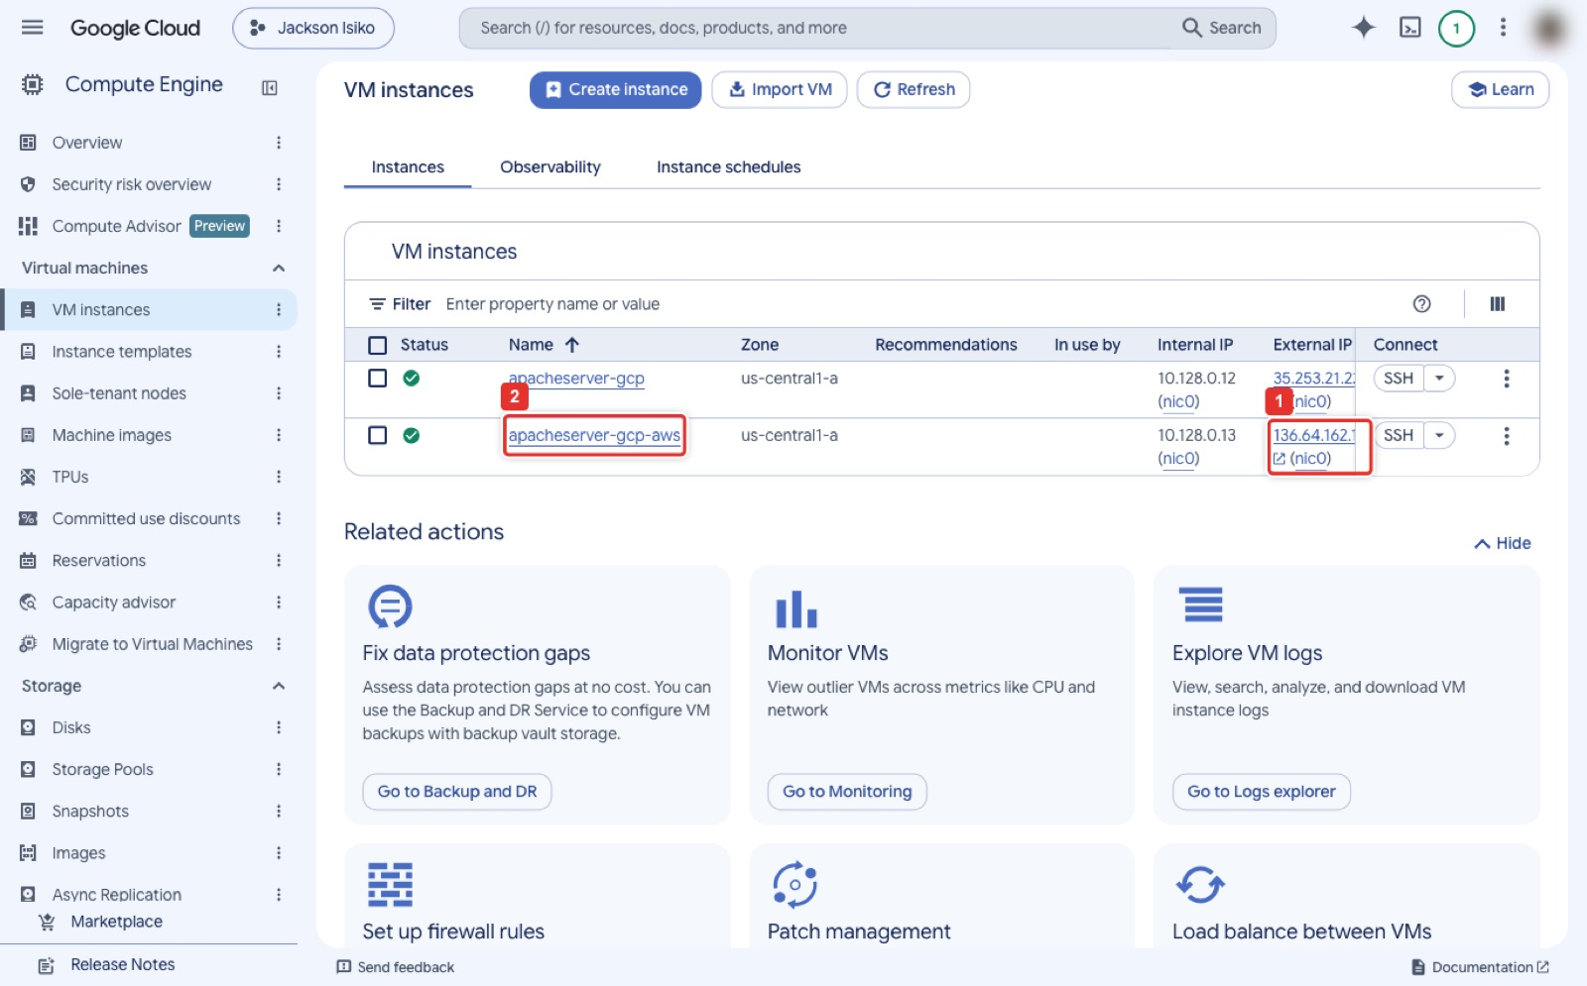
Figure 41. The External IP link opens the migrated site; the name link opens the VM details.
What you see: Compute Engine → VM instances with the migrated VM running. The External IP (1) is a link that opens http://<IP> in a new tab, where you should see the Apache page from AWS. The name link (2) opens the VM's details page. apacheserver-gcp above it is from the Azure variant of the lab.
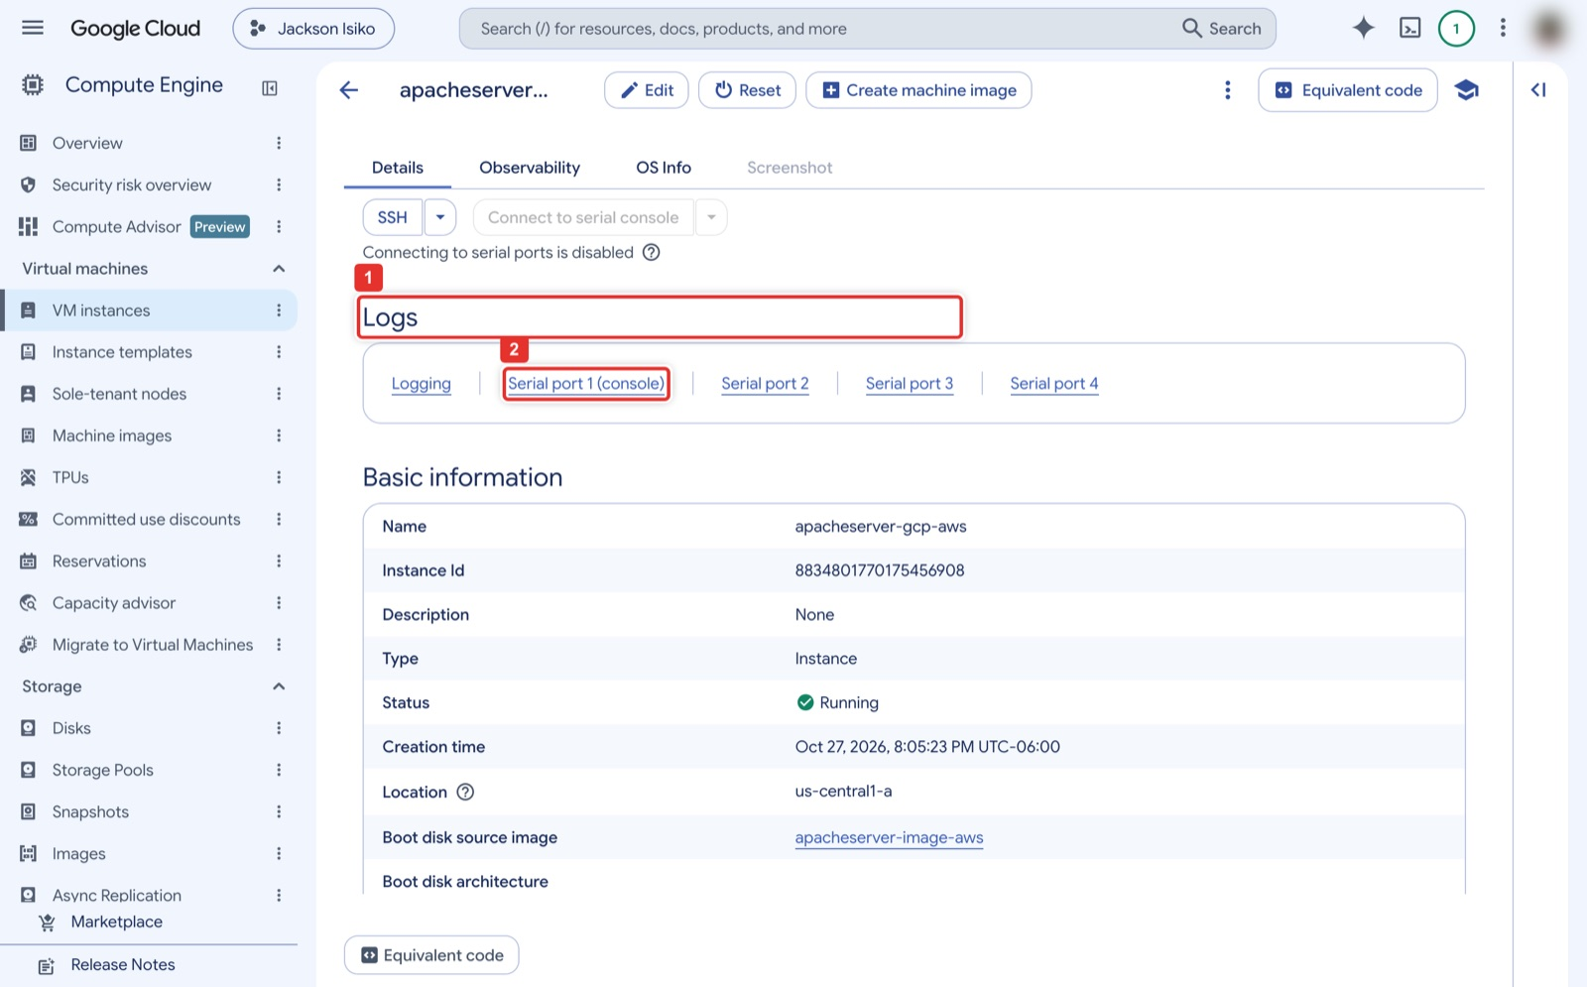
Figure 42. VM details → Logs → Serial port 1 (console).
What you see: The VM details page. Below the SSH button is the Logs row (1) with the links Logging and Serial port 1 (console) (2), followed by the Basic information table: status Running, the zone, and the Boot disk source image, which should name your custom image.
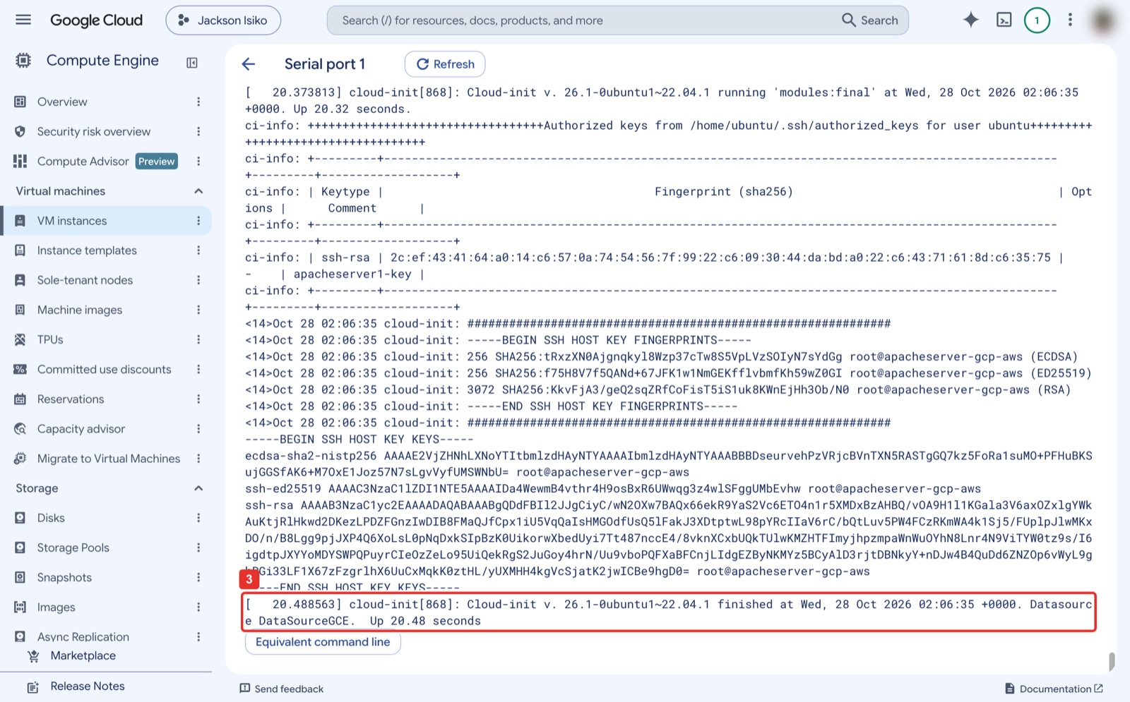
Figure 43. The serial output: cloud-init finished on the Google Compute Engine datasource.
What you see: The serial port 1 output, the text the VM writes to its console while booting. Among the cloud-init lines are the SSH host key fingerprints and the authorized key copied over from AWS (apacheserver1-key). The last line (3) reads "Cloud-init ... finished ... Datasource DataSourceGCE": the migrated Ubuntu found Google's metadata server, so the cloud-neutral changes from Step 6 worked.
Google Cloud Shell
IP=$(gcloud compute instances describe apacheserver-gcp-aws --zone=us-central1-a \
--format="value(networkInterfaces[0].accessConfigs[0].natIP)")
curl -s -o /dev/null -w '%{http_code}\n' http://$IP/ # 200
curl -s http://$IP/migrated-from.txt # migrated-from: AWS ip-172-31-... 2026-...
gcloud compute instances get-serial-port-output apacheserver-gcp-aws --zone=us-central1-a | grep -iE "cloud-init.*finished|DataSourceGCE" | tail -2

Expected result
HTTP 200, your migrated-from line, and a cloud-init line that names DataSourceGCE. This is Checkpoint 3 (browser screenshot).

Step 18. From the inside
The copied disk does not yet have Google's guest agent, so gcloud compute ssh cannot push a key. Use the AWS key pair, which the disk still trusts, after allowing SSH from your own IP only.
Google Cloud Shell, then your laptop
MYIP=$(curl -s https://checkip.amazonaws.com)
gcloud compute firewall-rules create allow-ssh-admin --network=default --direction=INGRESS \
--action=ALLOW --rules=tcp:22 --source-ranges=$MYIP/32 --target-tags=http-server
# on your laptop (where the AWS .pem is):
ssh -i ~/.ssh/apacheserver1-key.pem ubuntu@<EXTERNAL_IP>
systemctl status apache2 --no-pager | head -3
cat /var/www/html/migrated-from.txt
sudo apt-get install -y google-guest-agent google-compute-engine # after this, gcloud compute ssh works

Expected result
Active: active (running) for apache2 on a host that now has a 10.128.x.x address. Screenshot the status line for Checkpoint 3.

Part E. Tear down both clouds

AWS
Console: where to click
EC2 → Instances: tick apacheserver1 (1), Instance state (2) → Terminate (delete) instance (3), confirm. Wait until the state reads Terminated.
Volumes: tick apacheserver1-scratch → Actions → Delete volume (the root volume disappears with the instance).
Security Groups: tick apacheserver1-sg → Actions → Delete security groups. Key Pairs: tick apacheserver1-key → Actions → Delete.

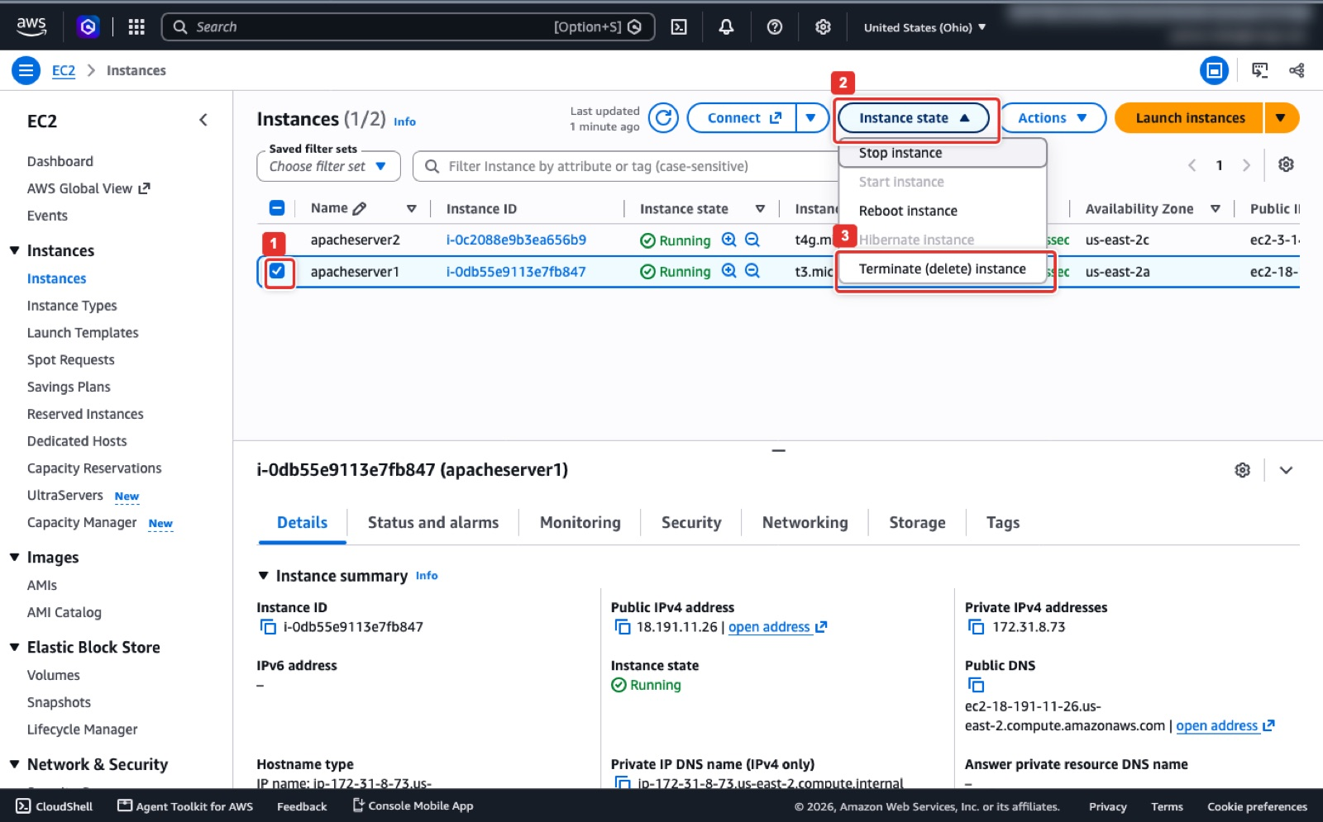
Figure 44. Instance state → Terminate (delete) instance.
What you see: EC2 → Instances with apacheserver1 ticked (1). Instance state (2) opens a menu with Stop, Reboot and Hibernate; Terminate (delete) instance (3) at the bottom removes the VM and its root volume after a confirmation dialog. Stop would keep billing the disk; Terminate is what the lab needs.
AWS CloudShell
aws ec2 terminate-instances --instance-ids <INSTANCE_ID>
aws ec2 wait instance-terminated --instance-ids <INSTANCE_ID>
aws ec2 delete-volume --volume-id <SCRATCH_VOLUME_ID>
aws ec2 delete-security-group --group-id <SG_ID>
aws ec2 delete-key-pair --key-name apacheserver1-key
aws ec2 describe-instances --filters Name=tag:Name,Values=apacheserver1 \
--query 'Reservations[].Instances[].State.Name' --output text # terminated, or nothing

Google Cloud
Console: where to click
Compute Engine → VM instances: tick apacheserver-gcp-aws (1) → More actions (2) → Delete (3), confirm. Images: tick apacheserver-image-aws (1) → Delete (2). Cloud Storage → Buckets: tick the bucket (1) → Delete (2) and confirm. VPC network → Firewall: delete allow-http and allow-ssh-admin if you created them.

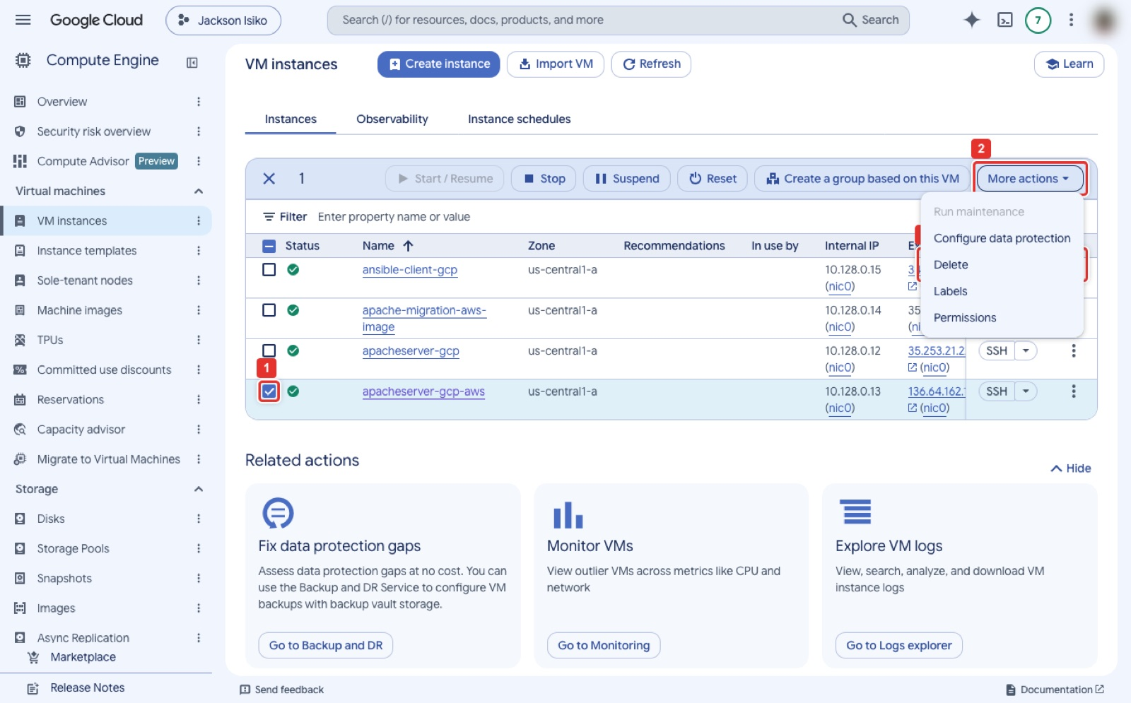
Figure 45. VM instances → tick the VM → More actions → Delete.
What you see: Compute Engine → VM instances with apacheserver-gcp-aws ticked (1). The toolbar changes to show Stop, Suspend, Reset and More actions (2); Delete (3) in that menu removes the VM and, by default, its boot disk after a confirmation dialog.
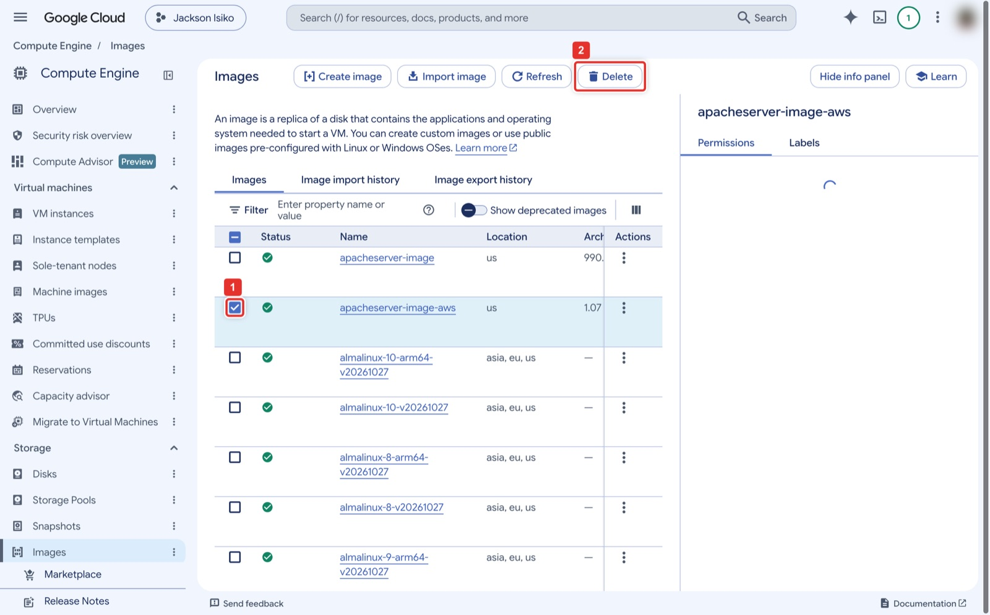
Figure 46. Images → tick the image → Delete.
What you see: Compute Engine → Images. Tick apacheserver-image-aws (1) and the Delete button (2) in the toolbar becomes active; the info panel on the right names the selected image. Confirm the dialog. Public images cannot be ticked.
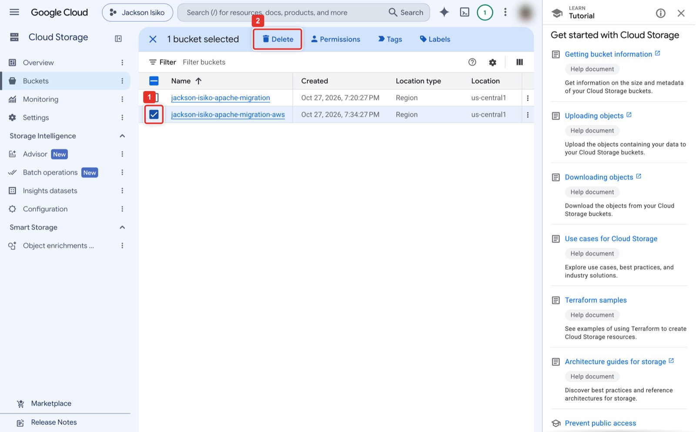
Figure 47. Cloud Storage → tick the bucket → Delete.
What you see: Cloud Storage → Buckets. Tick your bucket (1) and the toolbar changes to show 1 bucket selected with Delete (2). The dialog asks you to type the confirmation word because every object in the bucket is removed with it.
Google Cloud Shell
gcloud compute instances delete apacheserver-gcp-aws --zone=us-central1-a --quiet
gcloud compute images delete apacheserver-image-aws --quiet
gcloud storage rm -r gs://<PROJECT_ID>-apache-migration-aws
gcloud compute firewall-rules delete allow-http --quiet
gcloud compute firewall-rules delete allow-ssh-admin --quiet # only if Step 18 created it
gcloud compute instances list; gcloud compute images list --no-standard-images # both empty

Expected result
Both list commands print nothing from this lab. Screenshot the two empty lists and the Terminated state in AWS as the cleanup proof.

Appendix. Quick troubleshooting
Symptom | Cause | Fix
ssh hangs or times out | Your public IP changed, or you are in CloudShell with a different IP | Edit the SSH rule source to your current IP (Figures 17 and 18)
Block count lines differ in Step 7 | Stale superblock in the whole-disk cache | Delete disk.raw, repeat the capture block
curl -O gets 404 in Cloud Shell | Symlink missing, or wrong EC2 IP | Repeat Step 8, check with curl -I
Download stalls | Slow link | Re-run the same curl line; -C - resumes
images create: not a valid tar | Wrong tar format or file not named disk.raw | Repeat Step 12 exactly with --format=oldgnu -S
images create read timeout after 300 s | gcloud client timeout; the build continues | Poll gcloud compute images describe until READY
Browser times out on the GCP IP | No firewall rule, or VM without the http-server tag | Step 16; gcloud compute instances add-tags apacheserver-gcp-aws --tags=http-server --zone=us-central1-a
compute.networks.updatePolicy denied | Vocareum GCP lab role | Use a personal project or the existing default-allow-http rule
gcloud compute ssh permission denied | Guest agent not installed yet | SSH with the AWS key (Step 18), install the agent
Kernel panic at /sbin/init on the GCP VM | Capture was made with a stale superblock | Rebuild from Step 7; the block-count check catches it

Measured times on 2026-10-27: build and capture in AWS 7 minutes (afternoon) and 4.5 minutes (evening); transfer, convert and launch in Google Cloud 10 to 25 minutes depending on your link. Start the download before you take a break.

